Welcome to Nursery

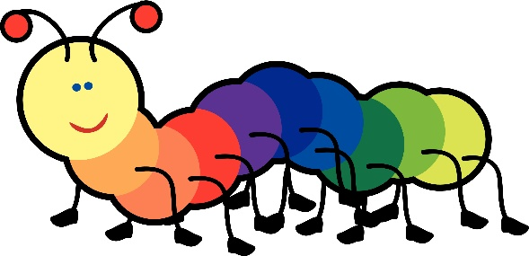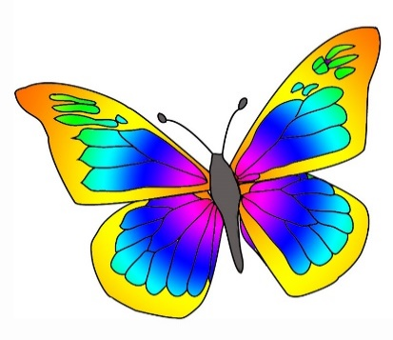

Caterpillars Butterflies
(2 yr olds) (3 and 4 yr olds)

