Find out about an endangered animal from a rainforest. - Which rainforest are they from? What do they eat? How do they get their food? Why are they endangered? What can be done to help? Be creative with the presentation.  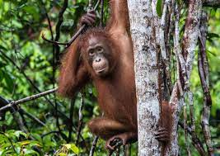 | Make some small models of rainforest animals. We might be able to use them in class!  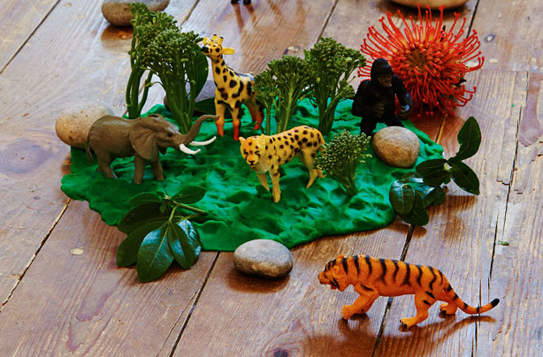 | Write your own maths problems related to the rainforest with answers e.g.  In a group of 12 parrots, 6 are blue, 3 are red and 3 are green. What fraction are blue?  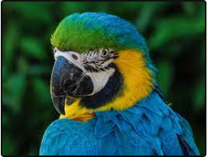 | 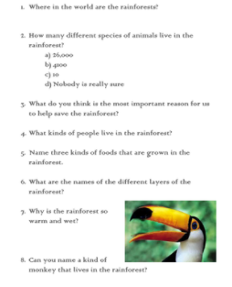  Use the internet to produce a quiz of 10 questions about the Amazon Rainforest & include answers.
Write a story set in the rainforest – it must be at least one side of A4 long.  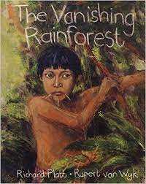 | Create a collage of pictures about the Amazon Rainforest.  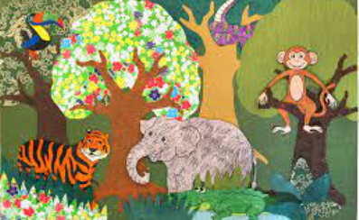 | Create a word search using words relating to the rainforest. | Draw a picture of your favourite rainforest animal. Make sure it is as realistic as possible.  