Term 5 - Once Upon a Time
R.E:
In R.E we will be looking at Judaism and looking at the Shabbat and Chanukah celebrations.
English:
This term we are reading the Three Little Pigs and alternative versions.
We will be looking at the characters in the book and writing different pieces of persuasive writing.
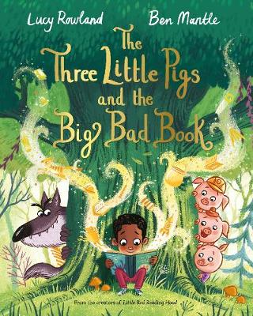
Geography:
We will be looking at geographical locations this term and comparing them to fairy tale locations. We will also be looking at picture maps and globes.
Art/DT:
In Art we will be learning about printing and using different objects to print and paint with.
In DT we will be learning how to make sliders and looking at the mechanisms that make them work.
Computing:
In computing we will be learning about data handling and learning how to make pictograms to display data.
PE:
In P.E we will be using co-ordination and control/consistency to perform different ball movements.
PSHE:
In PSHE we will be looking at relationships and discussion what makes a good friend and identifying the people who help us and how.
Music:
In music we will be learning different songs and listening to different music.
History:
In History we will be looking at castles and Kings and Queens.
We will be comparing fairy tale settings and making a class collage.
Science:
In science we are looking at Plants and Animals.
We will be looking at the plants and trees in our local area as well as animals such as birds, fish, reptiles and mammals.
Maths:
In Maths we will be looking at multiplication and division and fractions.
Topics will include:
Count in 2’s, 5’s and 10’s.
Making groups.
Making doubles.
Find a half and a quarter.

