**In Geography** we will be learning about human and physical geographical features. We will be learning words including: beach, cliff, coast, forest, hill, mountain, sea, ocean, river, soil, valley, vegetation, season and weather, city, town, village, factory, farm, house, office, port, harbour and shop.

**In English we will writing in a range of different styles including letters, reports, stories and descriptions.**

We will be continuing to develop our understanding of technical terms including noun, verb, adverb and adjective, apostrophe, comma, connectives, exclamations and questions.

We are learning to join our letters and it would help us to be encouraged to try this at home.

**In Reading we are focusing on comprehension and widening our vocabulary.**

We should be reading most words from sight, only needing to sound out strange new words. This will mean the speed of our reading increases. In Year 2, we should be reading **90 words a minute.**

Reading fluently allows us to focus on understanding what we have read. We are continuing to practice recalling facts from our reading, answering “why” questions and ordering statements from a text.

As a school we are also starting new reading schemes, which will mean that our home reading books will be changing. Keep an eye out for these exciting changes!

**In Science we will be learning about animals and their habitats.**

* Explore and compare the differences between things that are living, dead, and things that have never been alive.
* Identify that most living things live in habitats to which they are suited and describe how different habitats provide for the basic needs of different kinds of animals and plants.
* Identify and name a variety of plants and animals in their habitats, including microhabitats
* Describe how animals obtain their food from plants and other animals, using the idea of a simple food chain, and identify and name different sources of food.

**In Art** we will be creating an illustration in the style of Quentin Blake and exploring textures and colour.

**Thank you to all parents who regularly engage with dojo.**

Year 2 – Authors and Illustrators

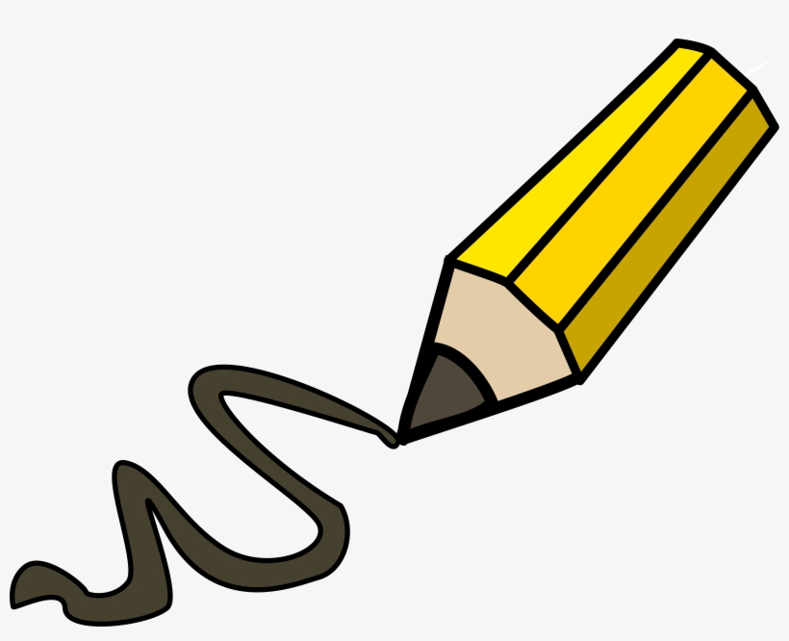

**In DT** we will be making character sliders.

**In History we will be learning about different authors and William Caxton.**

We will be learning about things from the past and how they compare with things in the present. We will be learning about famous historical figures.

**In Maths, we have been learning more about division. We will now be moving on to statistics and then properties of 2D and 3D shapes.**

**Fractions:**

- Recognise, find, name and write fractions ½, ¼ ¾, 1/3 and 2/4 of a length, shape, set of objects or quantity

- Write simple fractions for example, ½ of 6 = 3 and recognise the equivalence of 2/4 and ½.

**Length and Height:**

- Choose and use appropriate standard units to estimate and measure length/height in any direction (m/cm) using rulers.

- Compare and order lengths, mass, volume/capacity and record the results using >, < and =

**Revision:**

With SATs approaching in May, we will be continuing to practice SAT style questions and having small practice sessions. We will also be looking back over our learning so far and practicing any difficult areas again.