**In English we will writing in a range of different styles including posters, stories, recounts, newspapers, and instructions.**

We will be continuing to develop our understanding of technical terms including noun, verb, adverb and adjective, apostrophe, comma, connectives, exclamations and questions.

We are learning to join our letters and it would help us to be encouraged to try this at home.

**In DT** we will be planning and making our own clay dinosaur fossils and papier mâché eggs! Any newspaper donations greatly appreciated.

Year 2 - Dinosaurs

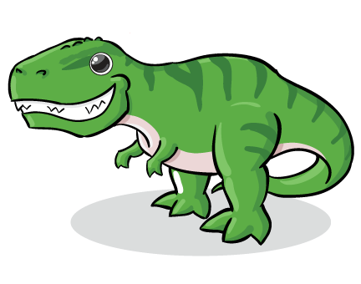

**In Reading we are focusing on comprehension and widening our vocabulary.**

We should be reading most words from sight, only needing to sound out strange new words. This will mean the speed of our reading increases. In Year 2, we should be reading **90 words a minute.**

Reading fluently allows us to focus on understanding what we have read. We are continuing to practice recalling facts from our reading, answering “why” questions and ordering statements from a text.

As a school we are also starting new reading schemes, which will mean that our home reading books will be changing. Keep an eye out for these exciting changes!

**In Science we will be learning about plants.**

* I can observe and describe how seeds and bulbs grow into mature plants.
* I can find out (through experiments) and describe how plants need water, light and a suitable temperature to grow and stay healthy.

**In History we will be learning about Mary Anning and fossils.**

We will be learning about things from the past and how they compare with things in the present. We will be learning about famous historical figures.

**In Art we will be creating a class dinosaur scene.**

I am developing a wide range of art and design techniques in using colour, pattern, texture, line, shape, form and space.

**In Maths, we have been learning more about division. We will now be moving on to statistics and then properties of 2D and 3D shapes.**

**Division:**

We have learnt to divide by making groups and by sharing. We have practiced SAT style questions with these, and realised that drawing pictures is a big help!!

**Statistics:**

We will be making and answering questions about tally charts, pictograms and bar charts. We will be learning the importance of looking at the key and axis to see what scale our charts go up in.

**2D and 3D Shape:**

We will be learning to identify and describe properties of 2D shapes, including the number of sides and lines of vertical symmetry.

We will be learning to identify and describe properties of 3D shapes, including edges, vertices and faces, including identifying 2D shapes on the surface of 3D shapes (for example, a circle on a cylinder).

**Thank you to all parents who regularly engage with dojo.**