Superhero Homework
Sketch or paint a picture of your favourite Superhero.  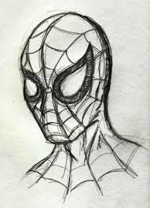 | Make a healthy snack for a Superhero. (Take a photo to share)  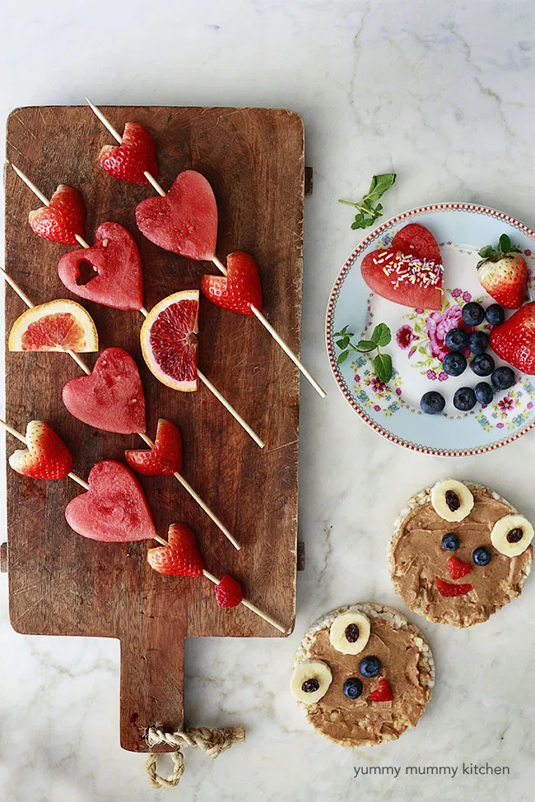 | Make your own Superhero mask.  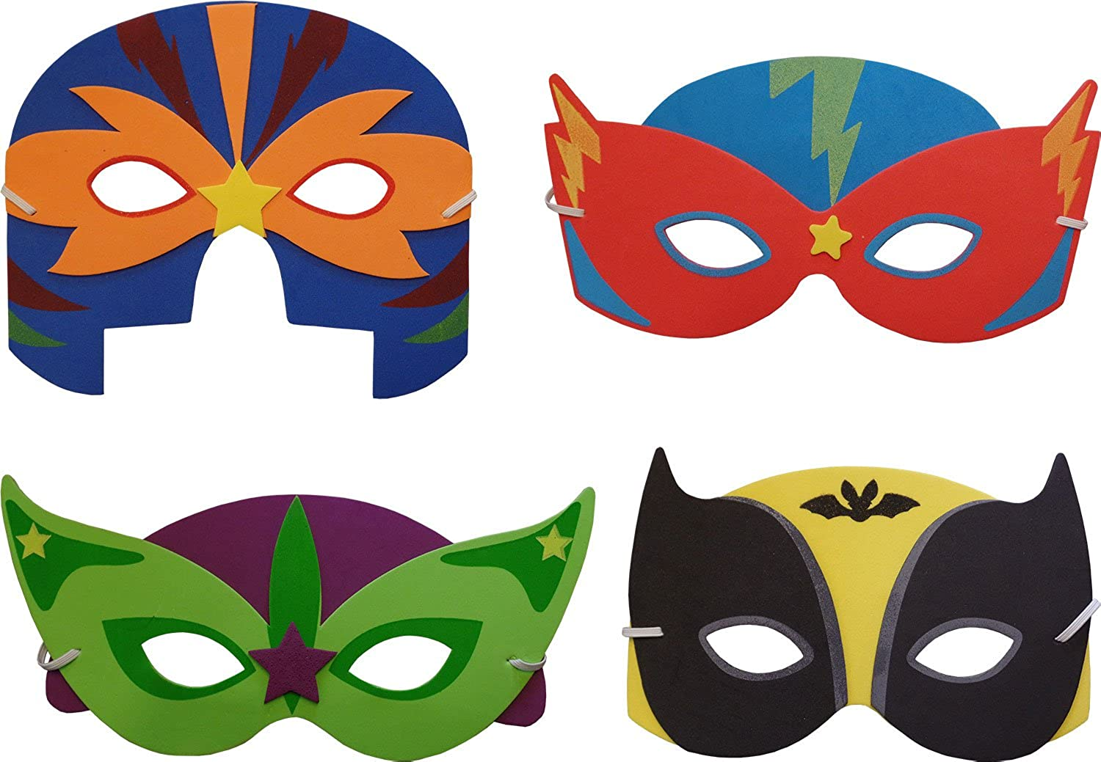 | Design and make an obstacle course to keep a Superhero fit!  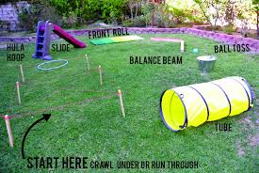
Create a short Superhero comic strip.  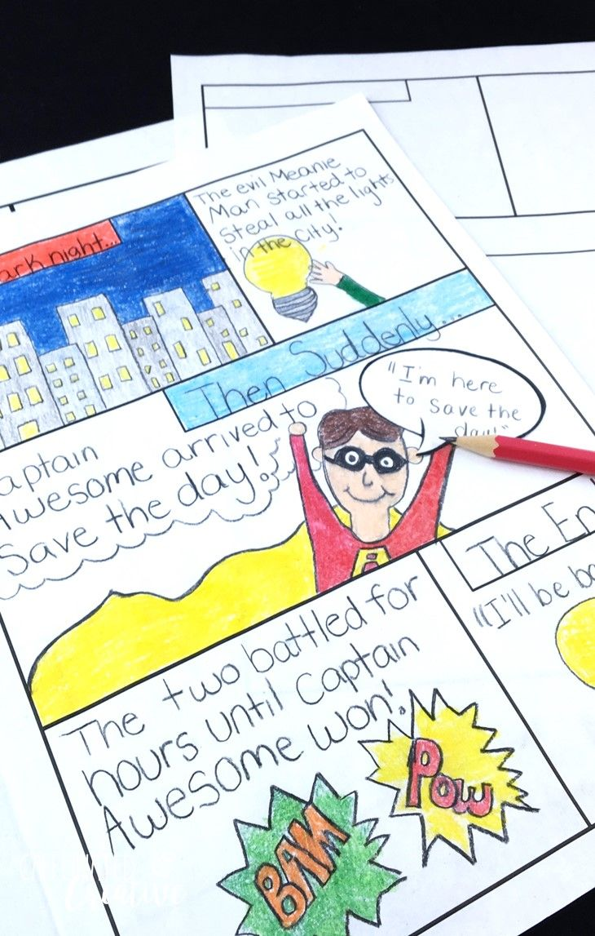 | Write an acrostic poem about superheros.  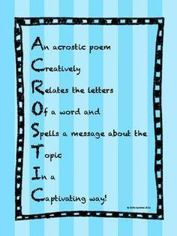 | Who is your real life superhero? draw a picture of them and a short description of why you have chosen them.  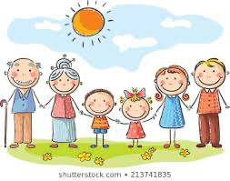  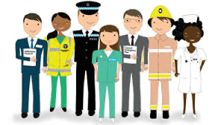 | Create a superhero handprint  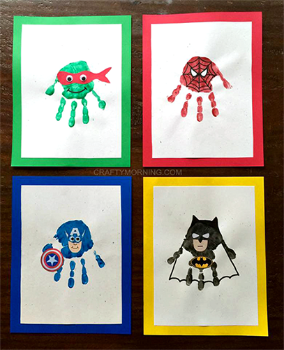
Come up with your own superhero name and design your own superhero logo  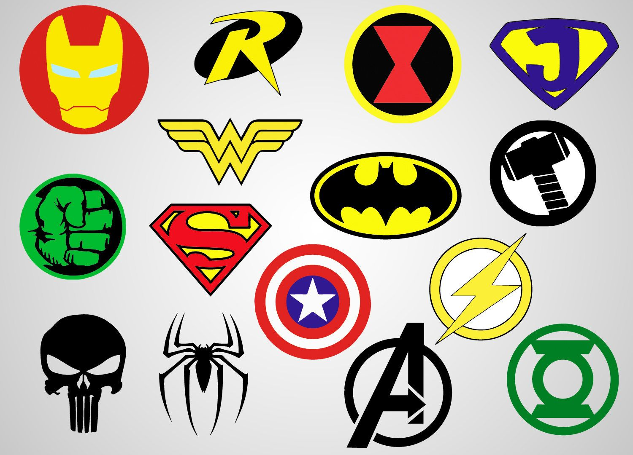 | Create your own superhero cuffs.  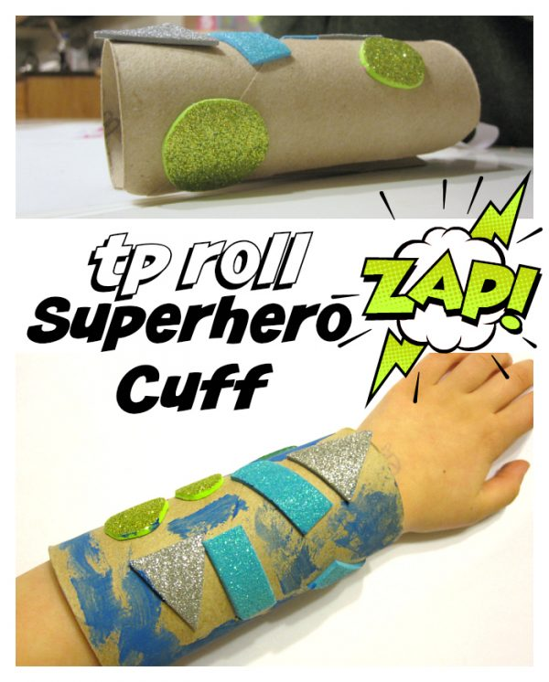 | Be a hero at home and see how many different ways you can help in one day.  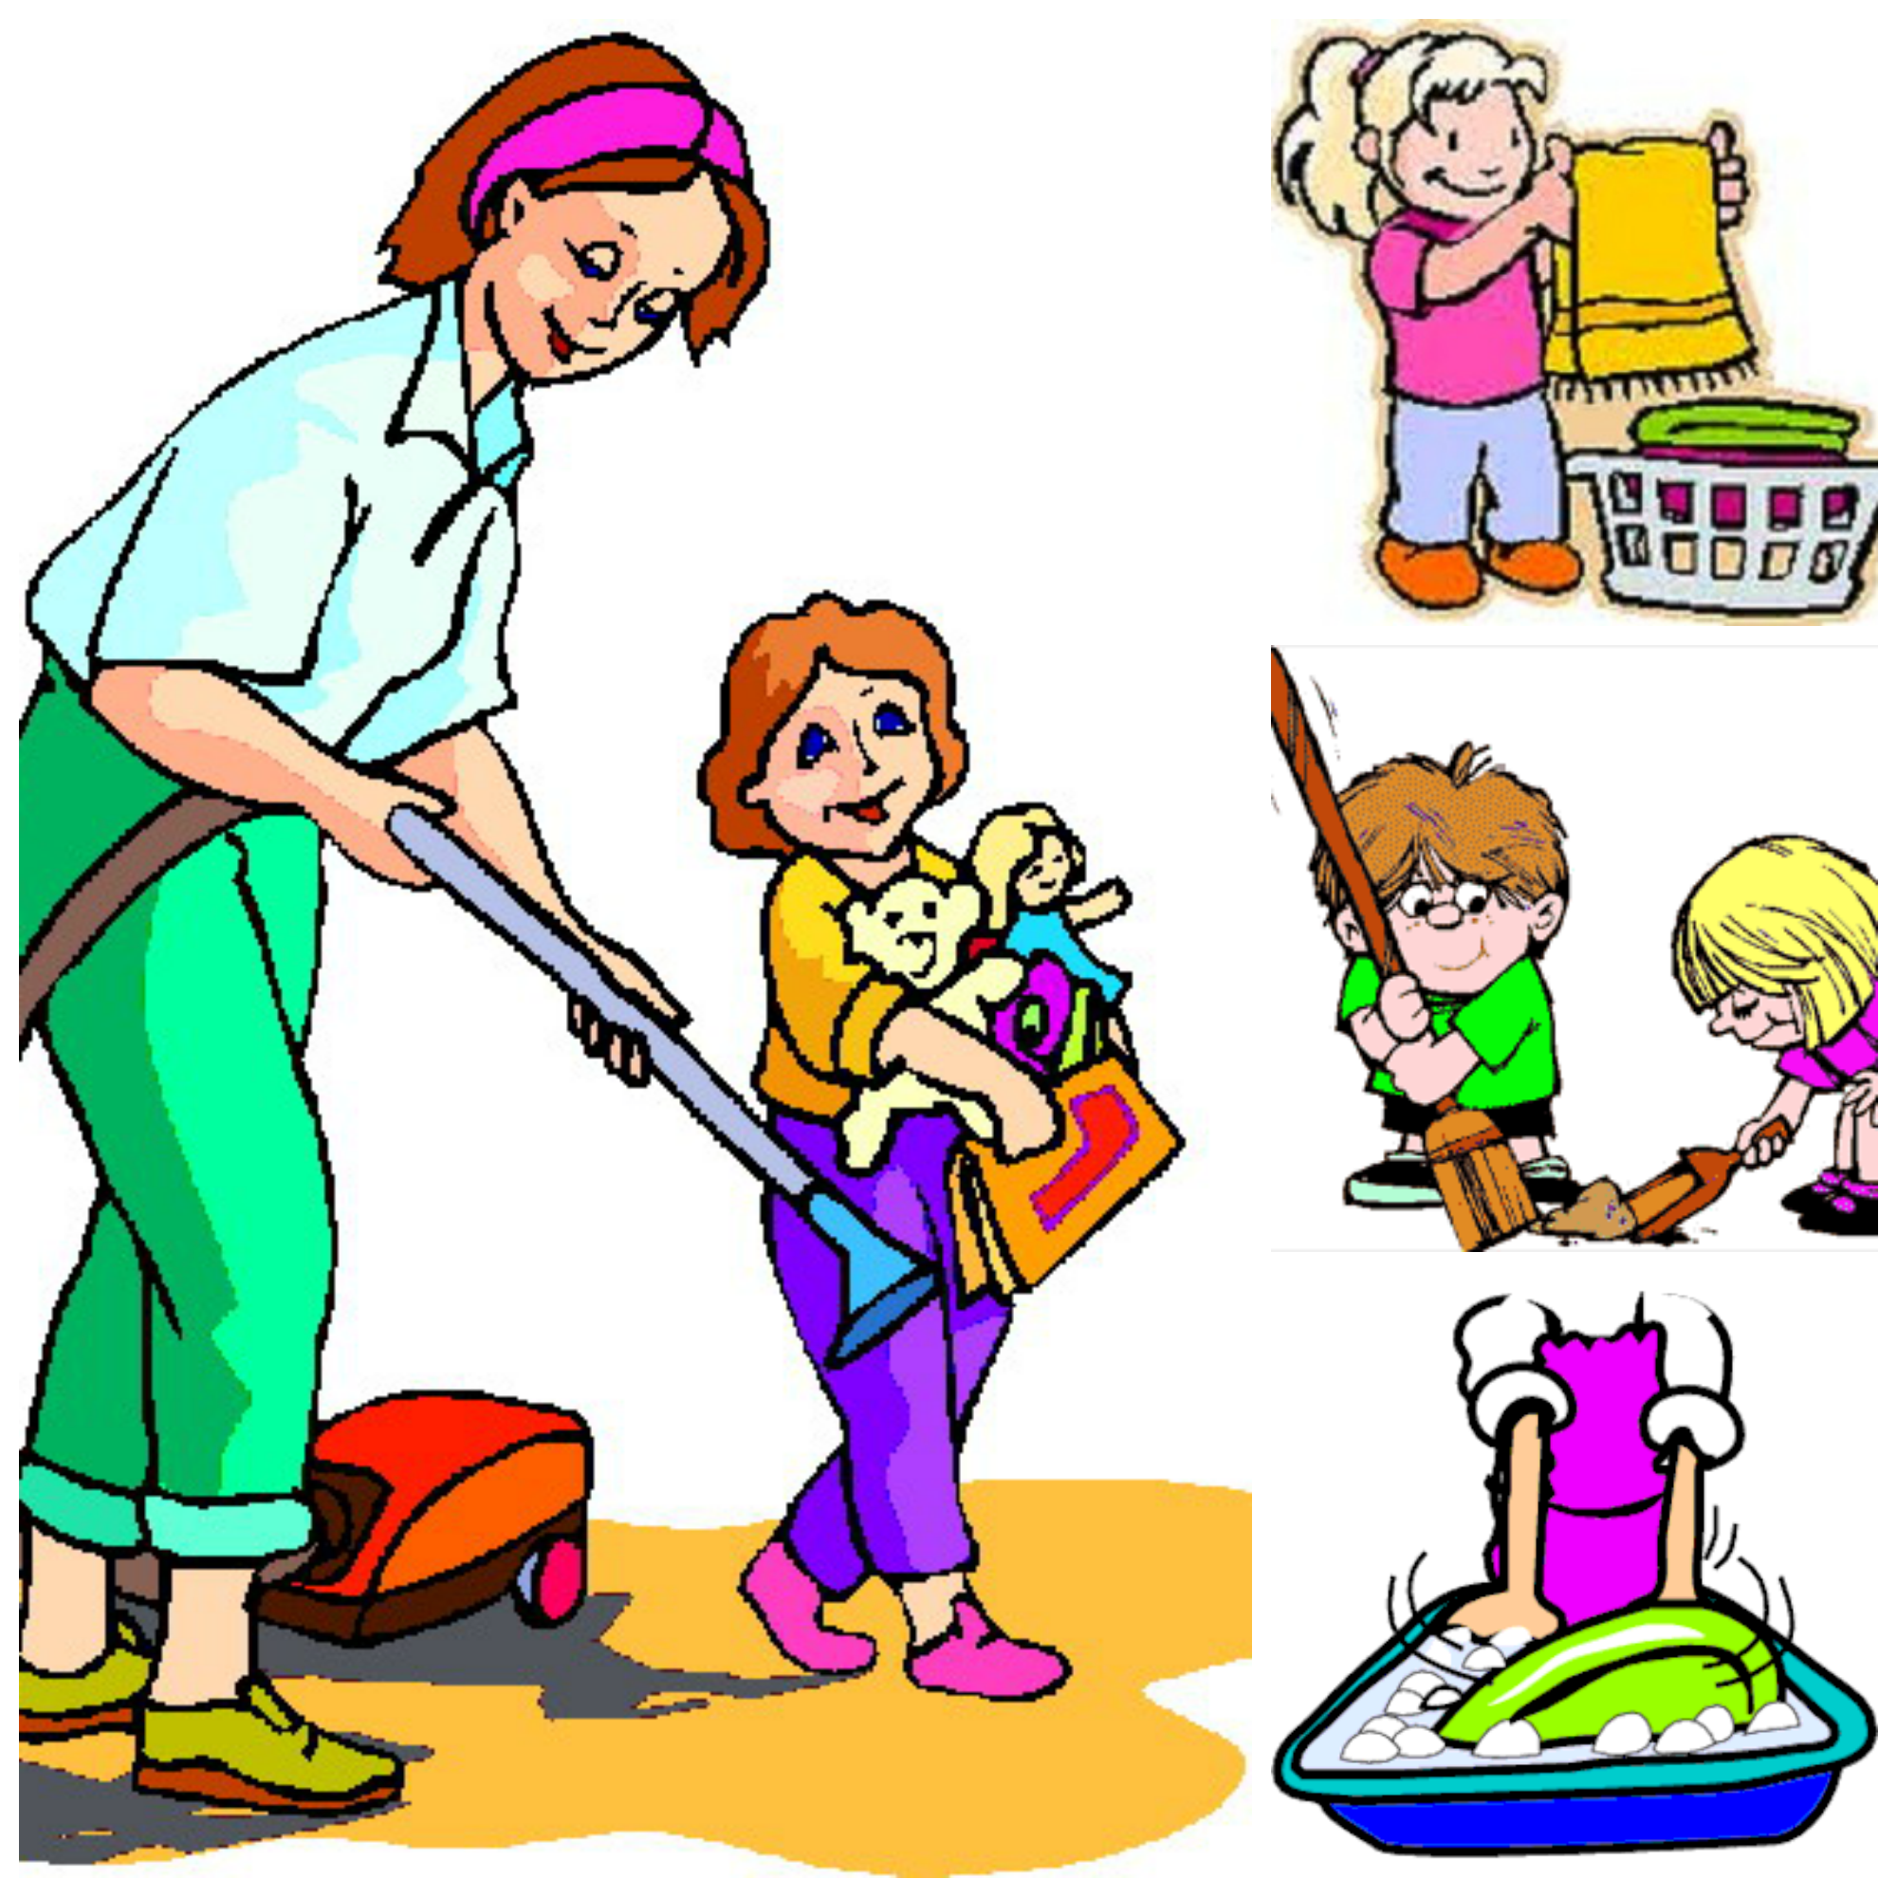 | Create your own superhero puppets.  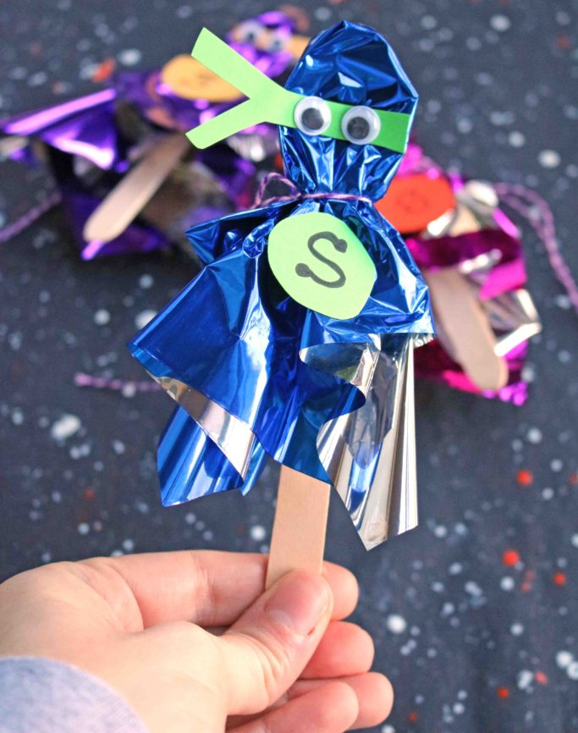
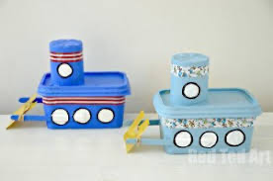  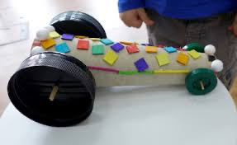  Make a junk model vehicle for a superhero to use on a mission. | If you could have a superpower what would it be? Draw a picture and describe how you would use your powers to help others.  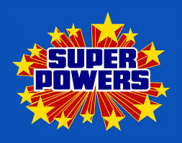 | Can you make up your own superhero theme song or sing your favourite? share your videos with us on class dojo. | Research real life human achievements and tell us your favourite (and why?).
Pick four Superhero project homework tasks and earn 10 dojo’s per completed project.
Hand in date - Monday 19th October. We look forward to seeing your creations!
Mrs Crane, Mr Hanks and Miss Bickle

