RAILWAYS HOMEWORK
Junk model a train  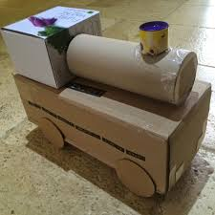 | Use LEGO to build a train  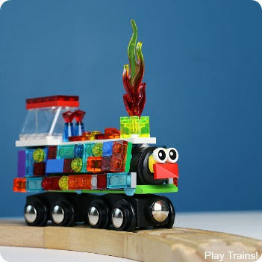 | 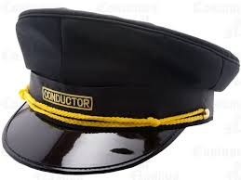  Make a Train conductor hat | Take some photos of trains  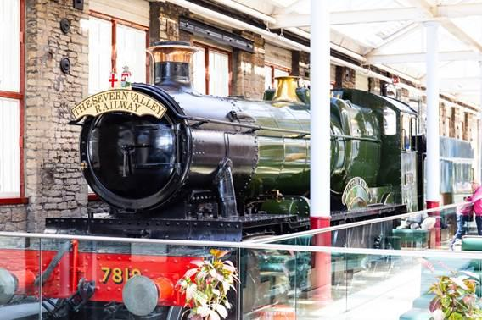
Create a word search with train/railway words | Write an acrostic poem about trains/railways  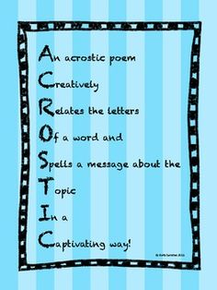 | Research the Flying Scotsman  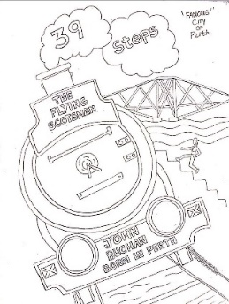 | Go to STEAM and write about your day
Create your own dot to dot of a train  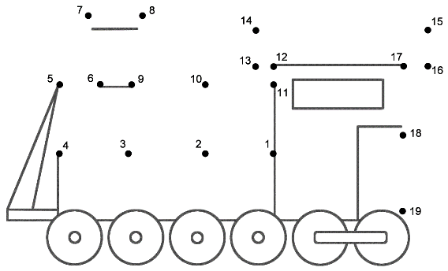 | Design and make a new train station for Swindon | 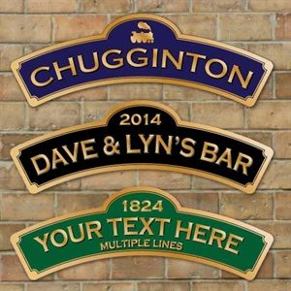  Make a train station sign | Draw or paint a train  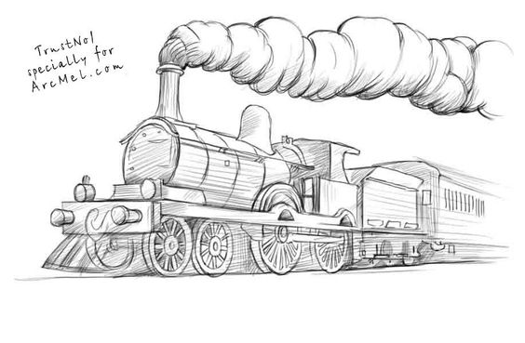
Pick 3 of the homework choices and bring in your work on Wednesday 9th December.
Earn some house points for your fantastic creations

