Polar Express Homework
Sketch or paint a picture of Isambard Kingdom Brunel.  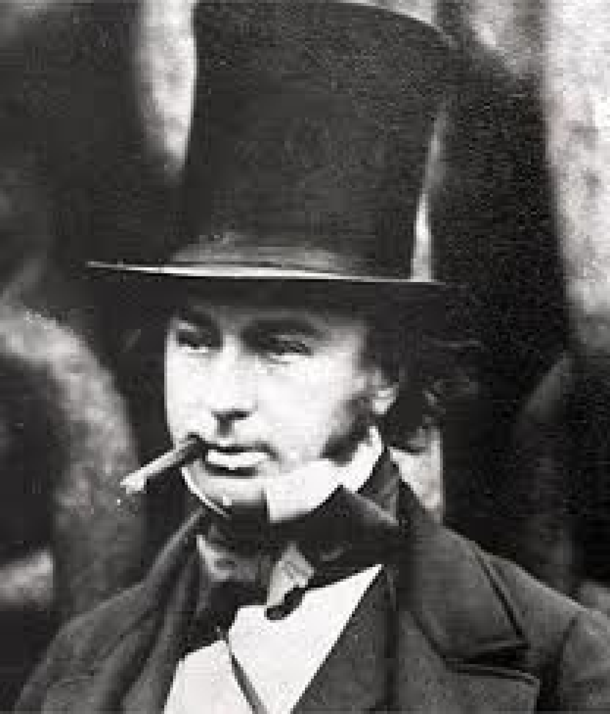 | Bake some biscuits to take with you on a train journey.  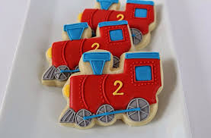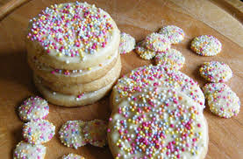 | To use a cook pot to create steam and describe what you see. | Visit the Steam Museum! (After lockdown!)  Send in some photos or write about your visit.  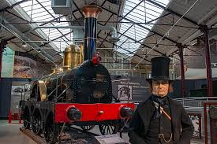
Visit the statue of Isambard Kingdom Brunel in the town center. Take a picture and send it in.  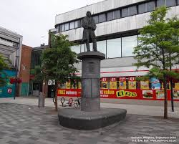 | Hot chocolate experiment…  Does hot chocolate powder dissolve faster in hot water or cold water?  Can you time it?  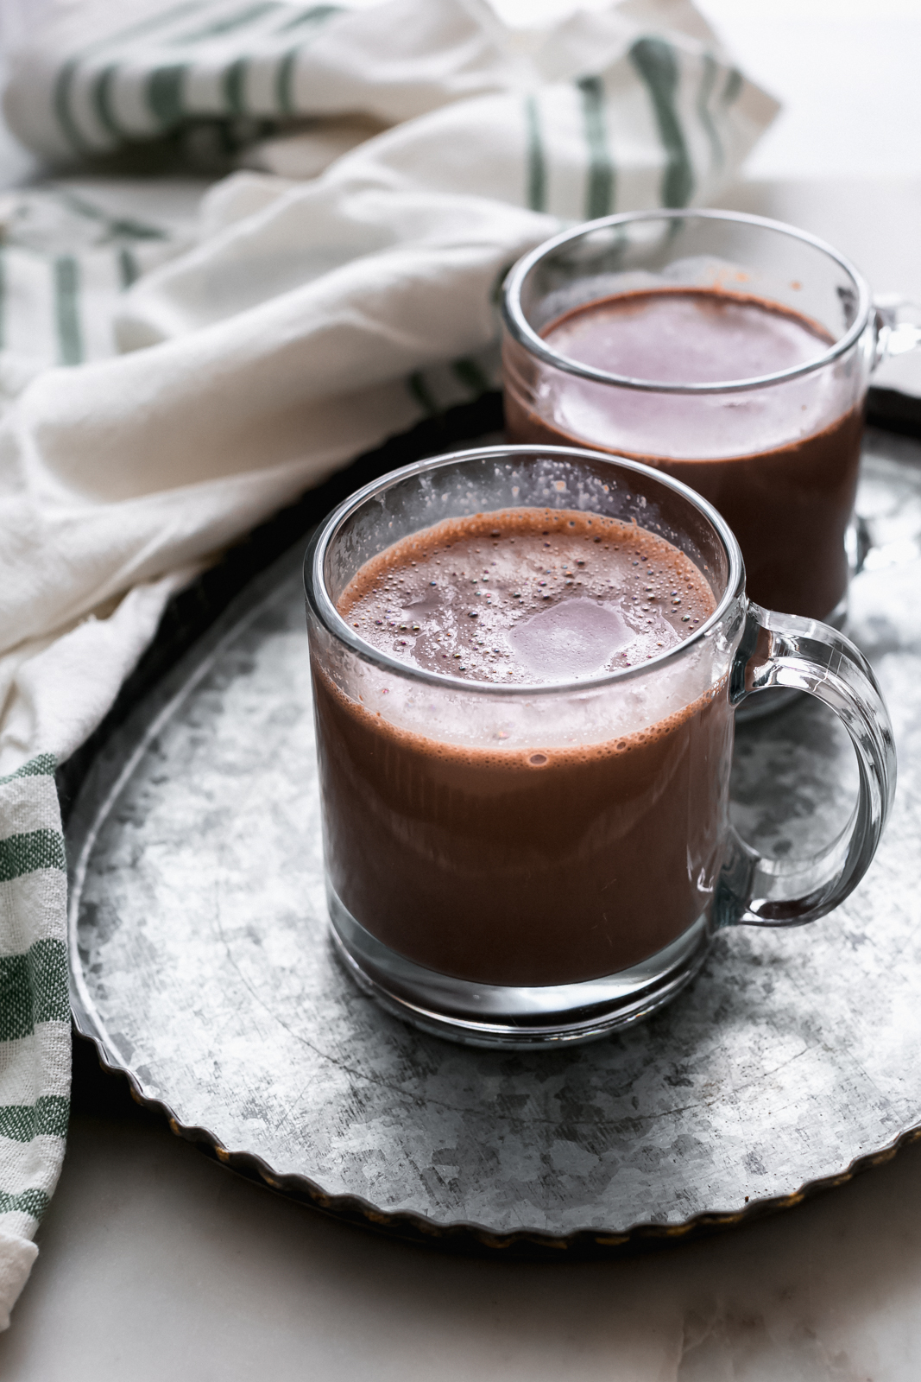 | Take a trip on a real train! (After lockdown!)  Send us a video or pictures of your adventure! (Extra points for a steam train!)  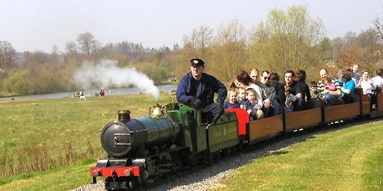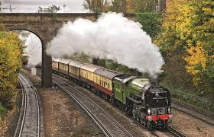 | 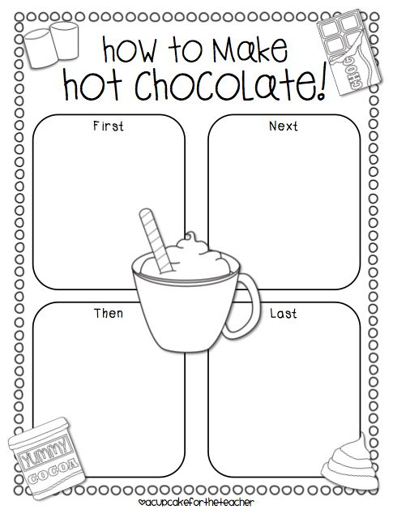
Create your own christmas card.  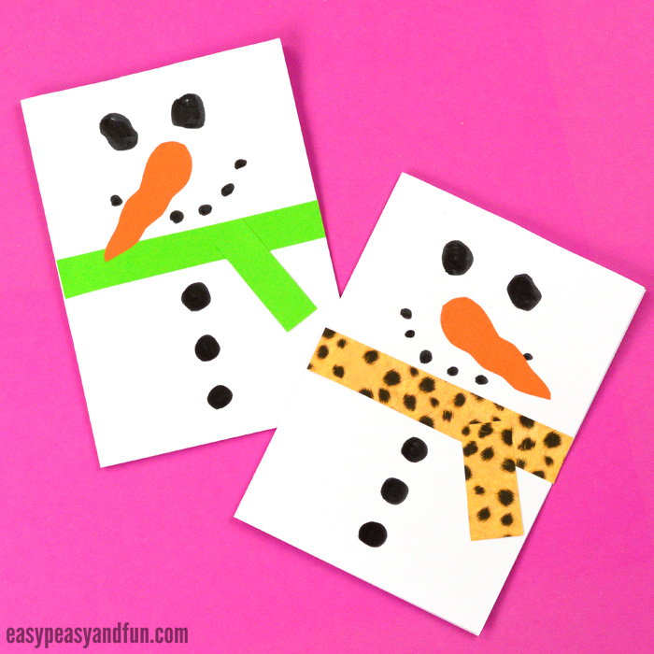 | Can you find out what different animals live in the north pole? (Arctic)  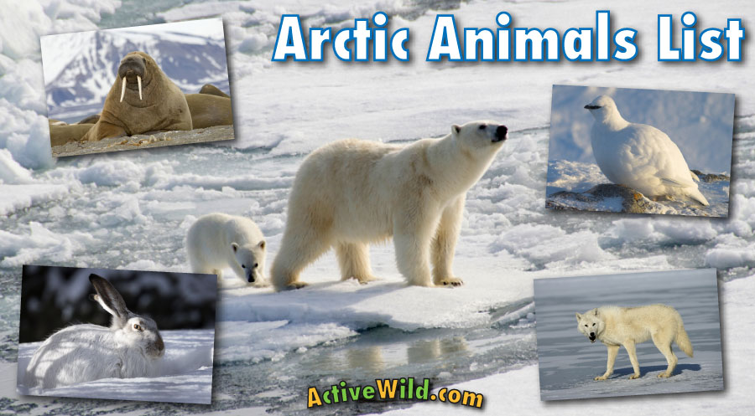 | Create your own Christmas carol. | If you could get on a train and go anywhere in the world… Where would it be and why?  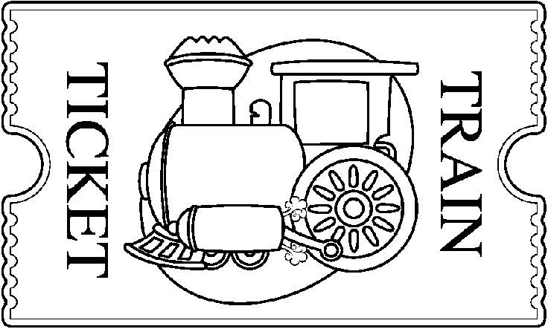
Make a junk model train like in the story Polar Express.  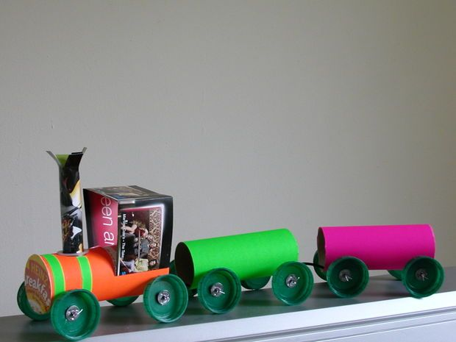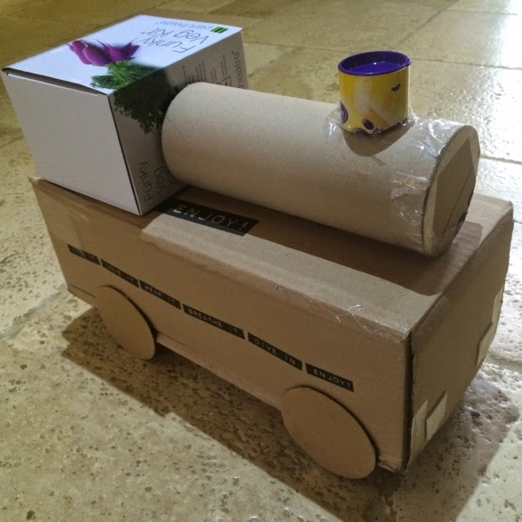 | Use your printing skills from Art, to print your own Christmas wrapping paper.  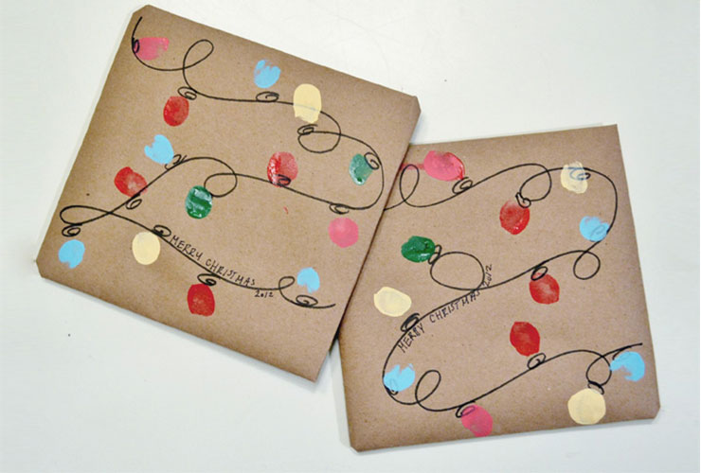 | Can you create your own Polar Express train ticket?  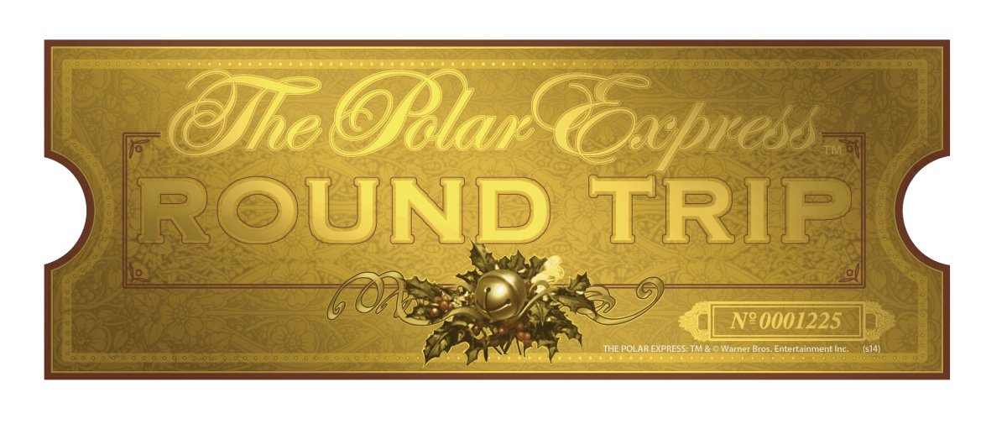 | Research about the Great Western Railway. Write down some of your favourite facts.
Pick four (or more) Polar Express project homework tasks and earn 10 dojo’s per completed project.
Please send us pictures on Dojo once a task has been completed! We look forward to seeing your creations!
Mrs Crane, Mr Hanks and Miss Bickle

