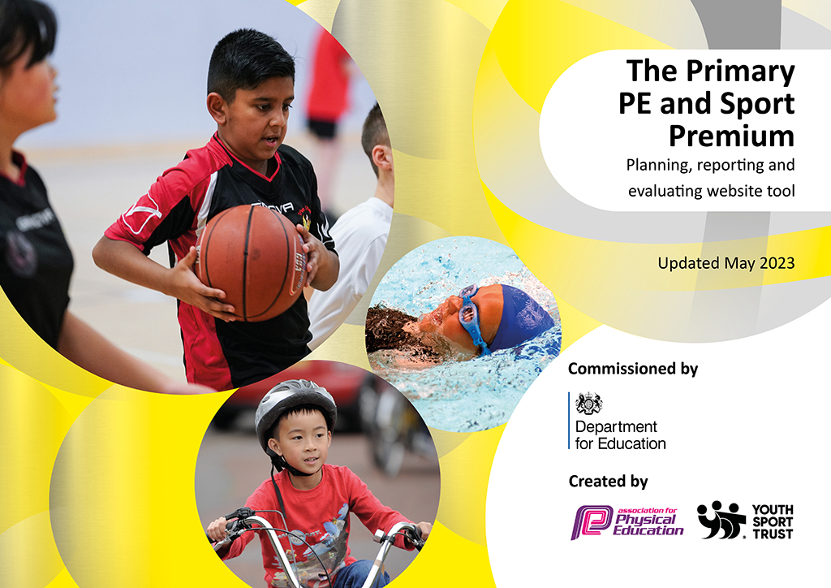
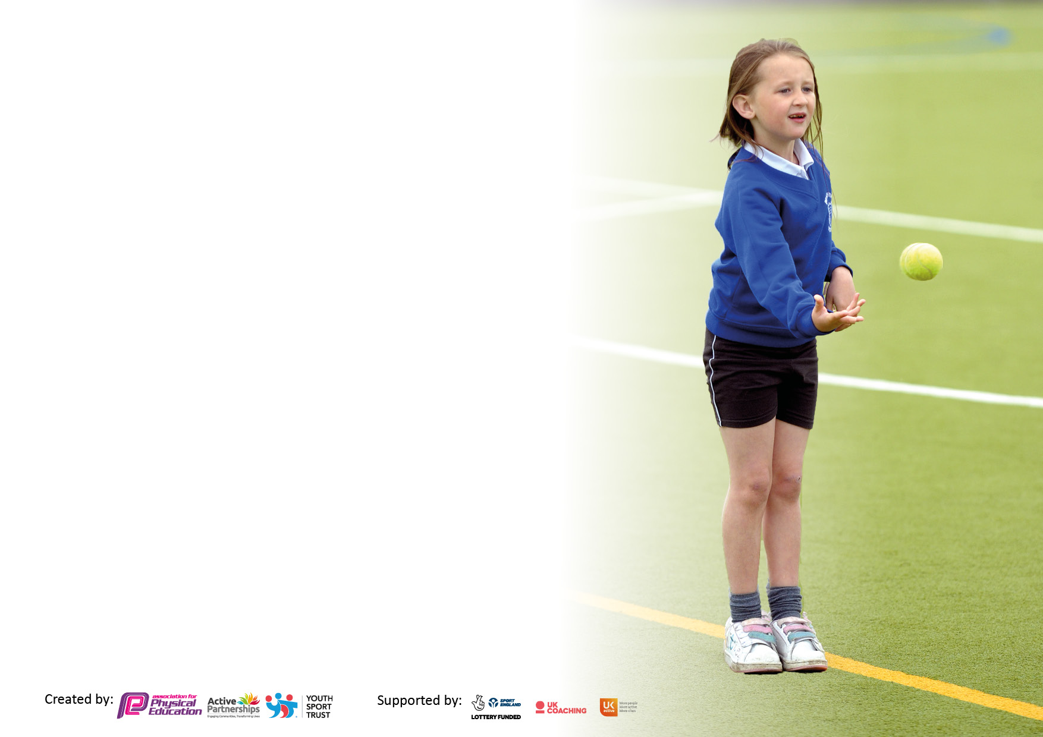

It is important that your grant is used effectively and based on school need. The Education Inspection Framework makes clear there will be a focus on ‘whether leaders and those responsible for governors all understand their respective roles and perform these in a way that enhances the effectiveness of the school’.

Under the Quality of Education Ofsted inspectors consider:
Intent - Curriculum design, coverage and appropriateness
Implementation - Curriculum delivery, Teaching (pedagogy) and Assessment
Impact - Attainment and progress

To assist schools with common transferable language this template has been developed to utilise the same three headings which should make your plans easily transferable between working documents.

Schools must use the funding to make additional and sustainable improvements to the quality of Physical Education, School Sport and Physical Activity (PESSPA) they offer. This means that you should use the Primary PE and sport premium to:

- Develop or add to the PESSPA activities that your school already offer
- Build capacity and capability within the school to ensure that improvements made now will benefit pupils joining the school in future years
- The Primary PE and sport premium should not be used to fund capital spend projects; the school’s budget should fund these.

Please visit gov.uk for the revised DfE guidance including the5keyindicatorsacrosswhichschoolsshoulddemonstrate an improvement. This document will helpyoutoreviewyourprovisionandtoreportyourspend.DfEencouragesschools to use this template as an effective way of meeting the reporting requirements of the Primary PE and Sport Premium.

We recommend you start by reflecting on the impact of current provision and reviewing the previous spend.

Schools are required to publish details of how they spend this funding, including any under-spend from 2021/2022, as well as on the impact it has on pupils’ PE and sport participation and attainment. The funding should be spent by 31st July but the DfE has stated that there will be no clawback of any unspent money so this can be carried forward into 2023/24.

We recommend regularly updating the table and publishing it on your website throughout the year. This evidences your ongoing self-evaluation of how you are using the funding to secure maximum, sustainable impact. Final copy must be posted on your website by the end of the academic year and no later than the 31st July 2023. To see an example of how to complete the table please click HERE.

Details with regard to funding
Please complete the table below.

Total amount carried over from 2021/22 | £0
Total amount allocated for 2021/22 | £18,350
How much (if any) do you intend to carry over from this total fund into 2022/23? | £0
Total amount allocated for 2022/23 | £18,470
Total amount of funding for 2022/23. Ideally should be spent and reported on by 31st July 2023. | £18,470
Swimming Data
Please report on your Swimming Data below.

Meeting national curriculum requirements for swimming and water safety.  N.B. Complete this section to your best ability. For example you might have practised safe self-rescue techniques on dry land which you can then transfer to the pool when school swimming restarts.  Due to exceptional circumstances priority should be given to ensuring that pupils can perform safe self rescue even if they do not fully meet the first two requirements of the NC programme of study | Data based on their Year 3 swimming in 2020 as no pool time available for top up swimming in 2023. Priority for 2023-2024 to ensure top up swimming is booked. (Dec 2023 booked)
What percentage of your current Year 6 cohort swim competently, confidently and proficiently over a distance of at least 25 metres?  N.B. Even though your pupils may swim in another year please report on their attainment on leaving primary school at the end of the summer term 2023.  Please see note above | 60%
What percentage of your current Year 6 cohort use a range of strokes effectively [for example, front crawl, backstroke and breaststroke]?  Please see note above | 49%
What percentage of your current Year 6 cohort perform safe self-rescue in different water-based situations? | 14%
Schools can choose to use the Primary PE and sport premium to provide additional provision for swimming but this must be for activity over and above the national curriculum requirements. Have you used it in this way? | Yes/No

Action Plan and Budget Tracking
Capture your intended annual spend against the 5 key indicators. Clarify the success criteria and evidence of impact that you intend to measure to evaluate for pupils today and for the future.

Academic Year: 2022/23 | Total fund allocated: | Date Updated:
Key indicator 1: The engagement of all pupils in regular physical activity – Chief Medical Officers guidelines recommend that primary school pupils undertake at least 30 minutes of physical activity a day in school |  |  |  | Percentage of total allocation:
 |  |  |  | 5.3 %
Intent | Implementation |  | Impact
Your school focus should be clear what you want the pupils to know and be able to do and about  what they need to learn and to  consolidate through practice: | Make sure your actions to achieve are linked to your intentions: | Funding allocated: | Evidence of impact: what do pupils now know and what can they now do? What has changed?: | Sustainability and suggested next steps:
Improve lunchtime resources to ensure children are actively engaged for at least 30 minutes during their lunch break.  Basketball backboards to enable children to practice their shooting skills during lunchtimes.  Outdoor activity climbing cube to improve strength and coordination. | Purchase equipment based on pupil voice and need outside. The equipment enables children to be active and improve skills in the core ABCs as well as taking part in sports activities such as hockey.  Basketball backboards will allow all children to be active during lunchtimes and enable them to develop their shooting skills.  The climbing cube allows children to improve their strength as they can hang from the top bars and swing and also moving their bodies through the different bars allows for coordination. | £475.98  £239.96  £259.99 | Children are given daily options of activities that are either adult led or independent.  Children have a variety of equipment that they can use outside to increase their physical activity levels and develop skills. They are also given the chance to participate in mini games such as hockey or football for example.  Impact will be seen in academic year 2023-2024 as only purchased in July 2023.  Children constantly use the frame during active breaktimes and lunchtimes. Teachers have noticed children developing their confidence in their own strength and coordination as they move through the frame or hang. | Equipment can be used in years to come and also with the set up of Play leaders in the future this equipment will ensure we are having active lunchtimes and our Year 5/6 children can implement activities and engage younger children.  Will be maintained and looked after to ensure they can be used for the foreseeable.  Will be maintained and looked after to ensure it can be used for the foreseeable.
Key indicator 2: The profile of PESSPA being raised across the school as a tool for whole school improvement |  |  |  | Percentage of total allocation:
 |  |  |  | 18.5%
Intent | Implementation |  | Impact
Your school focus should be clear what you want the pupils to know and be able to do and about  what they need to learn and to  consolidate through practice: | Make sure your actions to achieve are linked to your intentions: | Funding allocated: | Evidence of impact: what do pupils now know and what can they now do? What has changed?: | Sustainability and suggested next steps:
After school clubs for all children in KS1-KS2 variety of different types including multi skills, netball, football etc. Offering many clubs so children are excited by school sport, physical activity and therefore more engaged in PE lessons. | Offer clubs throughout the academic year to ensure all children have a chance to attend an afterschool club of their choice. Promote clubs through notice board and Dojo. | £3423.75 | Attendance at clubs was good and children enjoyed them.  Children from both KS1 and KS2 were in attendance. | More internal staff are willing to run clubs such as netball and football and we work closely with SJR Sports to offer clubs. May change to parents paying for clubs once club offer is more established next year.  Pupil voice needed to offer more clubs next year in 2023-2024.

Key indicator 3: Increased confidence, knowledge and skills of all staff in teaching PE and sport |  |  |  | Percentage of total allocation:
 |  |  |  | 9.6%
Intent | Implementation |  | Impact
Your school focus should be clear | Make sure your actions to | Funding | Evidence of impact: what do | Sustainability and suggested
what you want the pupils to know | achieve are linked to your | allocated: | pupils now know and what | next steps:
and be able to do and about | intentions: |  | can they now do? What has
what they need to learn and to |  |  | changed?:
consolidate through practice:
PE Subject leader release time to support staff in the delivery of PE.  New PE scheme to be purchased. | PE subject leader to team teach with staff to ensure they are happy with lesson delivery and any support with SEND children. Specific support to individual requests. Twilight training for all staff.  Purchase scheme and implement in September 2023. However, staff will have access from June 2023 to have training on how to use and deliver the new scheme. Twilight training to be given by PE subject leader July 2023. | £1222.87  £550 | Staff have been upskilled and feel more confident in their teaching and delivery of PE.  New scheme is progressive and clear for all staff to use. Training provided by subject leader was helpful and supportive and all staff know they can seek advice and support going forward. | Continue to provide release time for subject leader in order to upskill staff.  Evaluate new scheme by May 2024 in order to repurchase or change schemes once it has been implemented properly from September 2023.
Key indicator 4: Broader experience of a range of sports and activities offered to all pupils |  |  |  | Percentage of total allocation:
 |  |  |  | 48%
Intent | Implementation |  | Impact
Your school focus should be clear | Make sure your actions to | Funding | Evidence of impact: what do | Sustainability and suggested
what you want the pupils to know | achieve are linked to your | allocated: | pupils now know and what | next steps:
and be able to do and about | intentions: |  | can they now do? What has
what they need to learn and to |  |  | changed?:
consolidate through practice:
Provide children with opportunities to try new sports:  Swindon Town Football Club after school club.  Fencing  Dragon Ball  Football Freestyling  Dodgeball Club  Archery Set  Hayley admin time to organize clubs and other sporting activities.  Balanceability Scheme | Children will be offered the chance to attend clubs after school, experience a broader range of experience days with football freestyling workshops and dragon ball and the purchase of a new archery set to enable children to use this within PE lessons and at active lunchtimes.  Apart from Swindon Town football club as an after-school club for Year 3/4, everything else is new for our children. STFC help to support our children in the skills and development to play football matches to ensure we can take part in the football league in Year 5/6. Friendly matches are organized to also give children opportunities.  Fencing was delivered as a team-teaching opportunity for our UKS2 staff to acquire knowledge of a sport that is not within our usual curriculum delivery.  Balanceability is important to ensure our youngest children are developing their core skills within balance and coordination to enable them to be active at school during lunchtimes and also take those skills and use them outside of school as well. Many of our children do not have access to bikes so between the balance bikes and pedal bikes our children can practice this skill before they leave KS1. | £2,720  £1560  £495  £550  £427.50  £719.99  £450  £1934 | Children engaged and excited by new experiences.  Archery has now become part of our ‘normal’ PE curriculum due to the positive feedback from children during pupil voice.  Intra dodgeball competition planned for 2023-2024  Some children have been signposted to attend fencing clubs outside of school due to the experience they received at school.  Swindon Town football club after school club is full again for the next academic year due to children being excited and engaged by the coaching they receive and wanting to learn how to play competitive football.  Children have enjoyed learning a new sport with Dragonball and learning new skills with a football freestyler. Both involved the whole of KS1 and KS2 so active engagement was great.  Children to begin Balanceability scheme from September 2023 as only purchased in July 2023. | Continue to use funding to invite specialists in for new and exciting sports and activities that our children do not usually get a chance to experience.  Dodgeball Club will be delivered in house by internal staff.  Archery set to be maintained and staff to receive CPD to support the delivery of sessions both within PE and at lunchtimes.  Balanceability training for staff booked for October ‘23’  Bikes and equipment to be maintained regularly to allow for it to be used for many years to come.

Key indicator 5: Increased participation in competitive sport |  |  |  | Percentage of total allocation:
 |  |  |  | 18.6%
Intent | Implementation |  | Impact
Your school focus should be clear | Make sure your actions to | Funding | Evidence of impact: what do | Sustainability and suggested
what you want the pupils to know | achieve are linked to your | allocated: | pupils now know and what | next steps:
and be able to do and about | intentions: |  | can they now do? What has
what they need to learn and to |  |  | changed?:
consolidate through practice:
PE Essentials Membership Fortius  Netball posts and match balls purchased to enter the local netball league in 2023-2024.  Football goals to be purchased that are of a high quality so that we can enter the local football league in 2023-2024 | Membership will allow us to enter inter competitions for the year.  Currently do not have netball posts so need these in order to be able to teach netball within PE, as an after school club and of course for competitive inter games against other local schools within the league.  Current goals are broken and do not meet safety standards. | £250  £290.97  £2,899.99 | Unfortunately due to unforeseen circumstances there was a lack of competitions attended during the academic year 2022-2023.  Only received in July 2023 so impact will be evident in the next academic year.  Only received in July 2023 so impact will be evident in the next academic year. | Renew membership for 2023-2024 and with new PE subject leader in place, competitions are a high priority to attend.  Ensure correct maintenance so can be used for many years to come. Entry into the local netball league annually.  Ensure correct maintenance so can be used for many years to come.  Entry into the local football league annually.

Signed off by
Head Teacher: | Gill Young
Date: | 28/07/23
Subject Leader: | Emma Roberts
Date: | 28/07/23
Governor: | Simon Robins
Date: | 28/07/23

