Greece Lightning Homework!
Pick 3 of these projects to complete and earn a house point for each project. Bring your projects in by Wednesday 26th May.
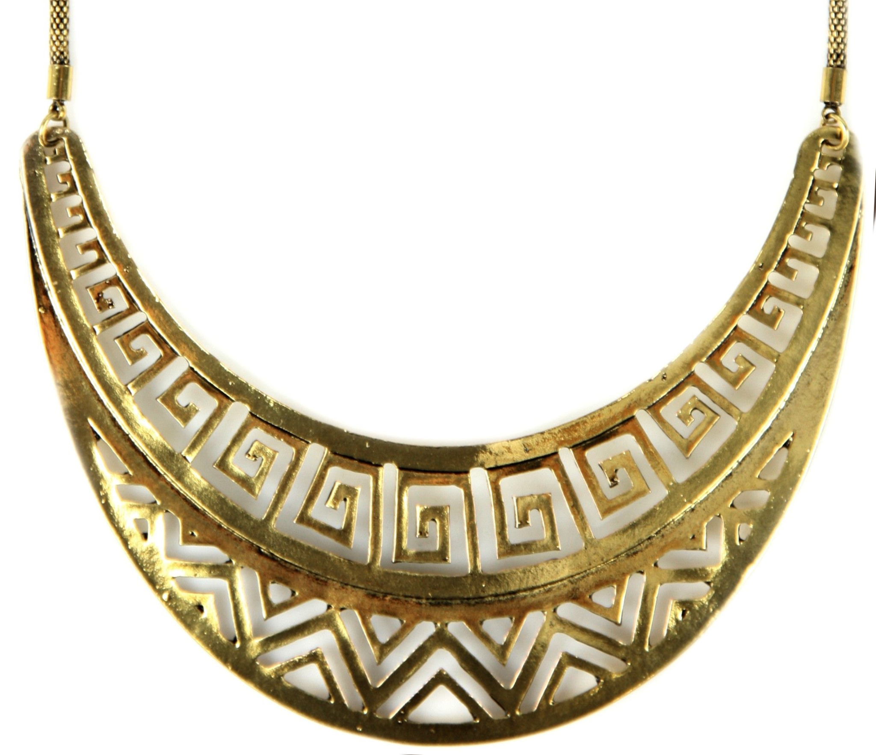  Design your own piece of jewelry. | Use string to make your own printing art.  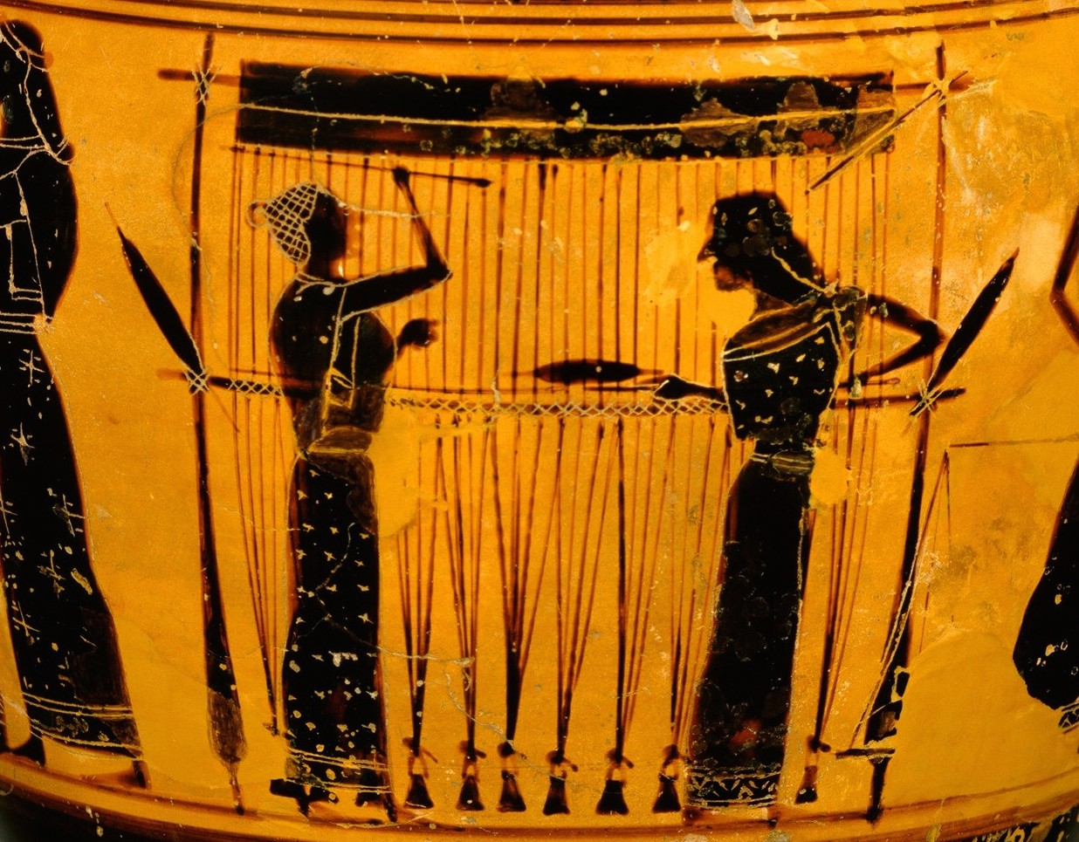 | Produce an information text on the Ancient Greeks.  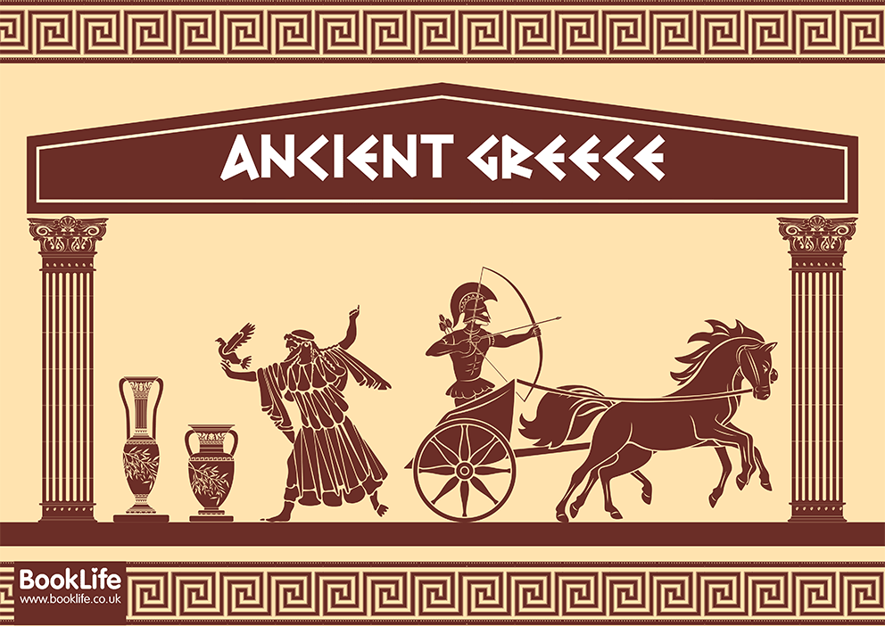 | Try some Greek food.  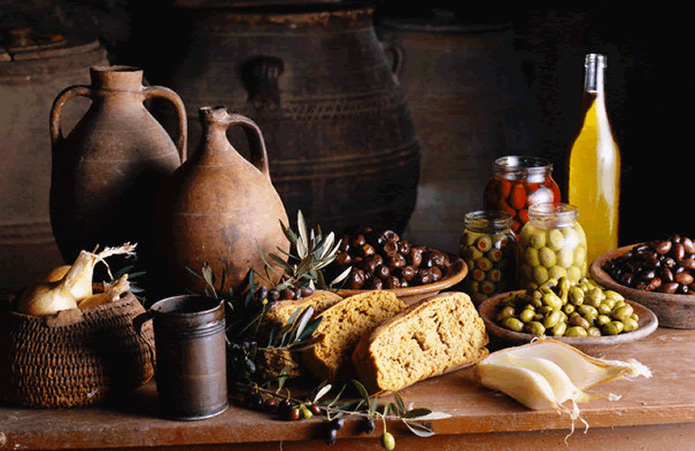
Write a poem based on the Ancient Greeks.  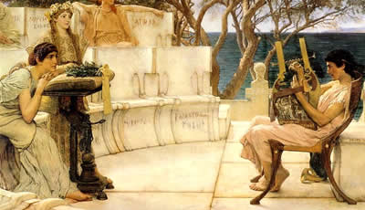 | 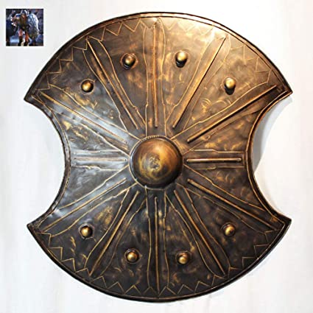  Design and make a shield. | Research Alexander the Great and present the information in your own way.  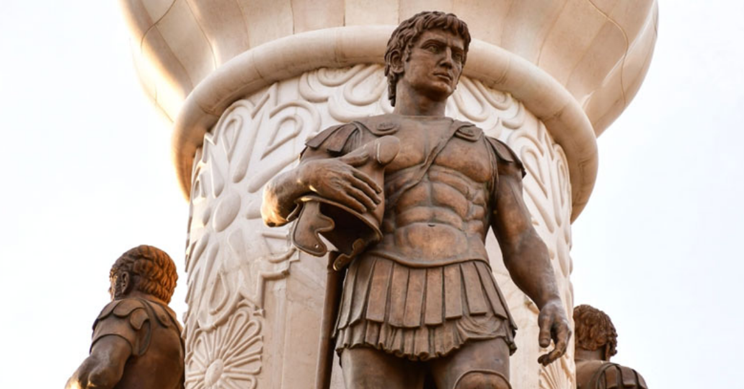 | Plant a seed/bulb and keep a plant diary, watching it grow.
Create your own Greek God/Goddess.  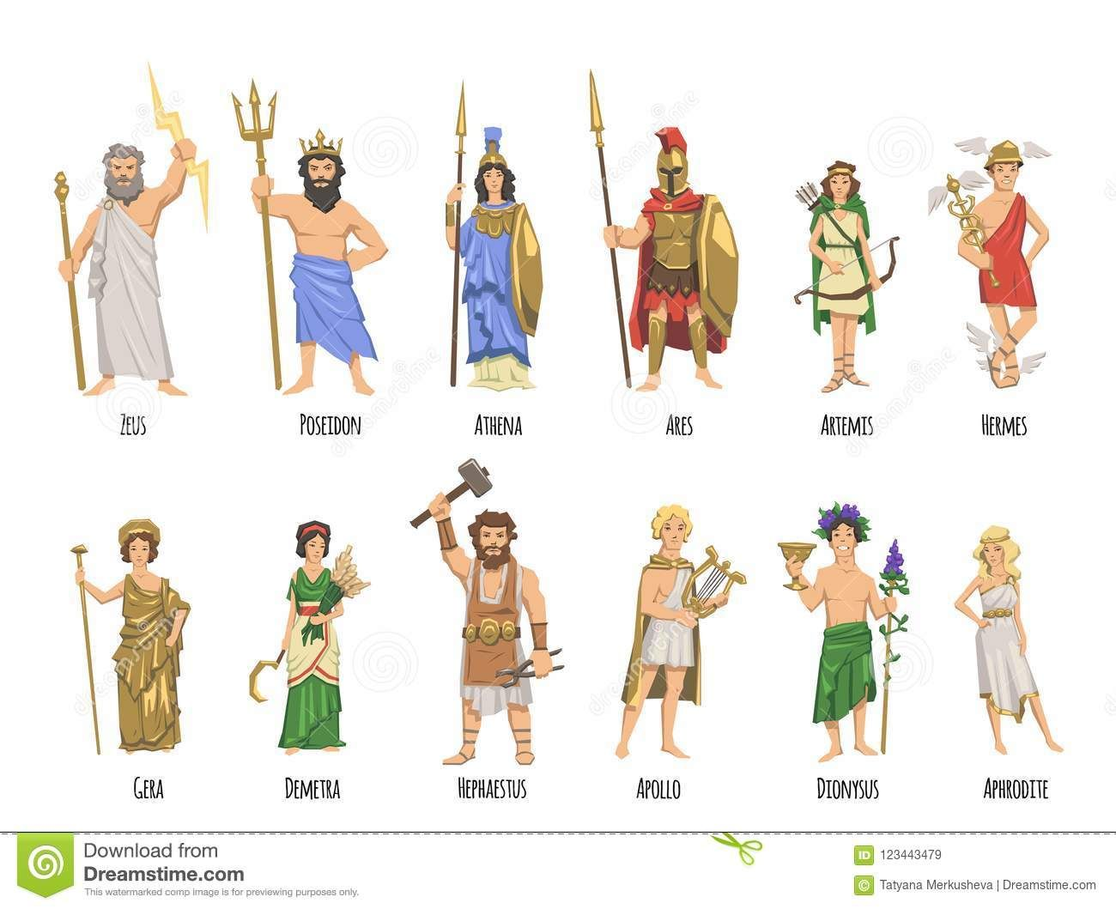 | Make a Colosseum.  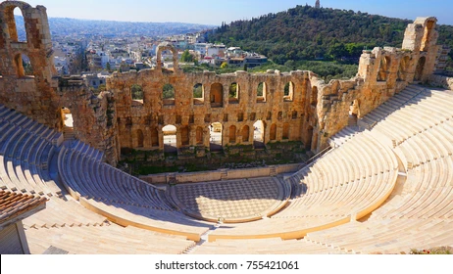 | Create a holiday brochure for Greece. | Make your own version of an Ancient Greek outfit.  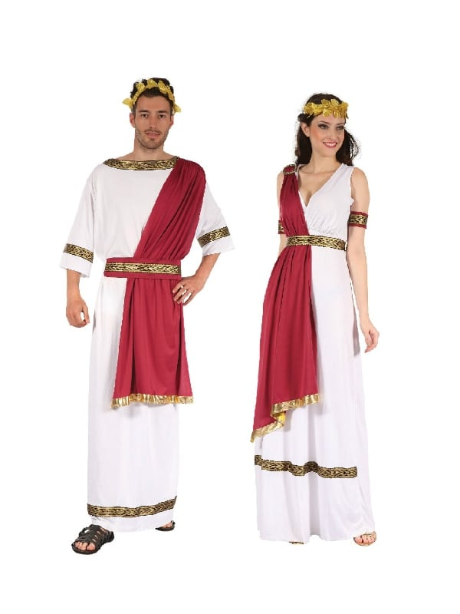
Make a Greek inspired meal.  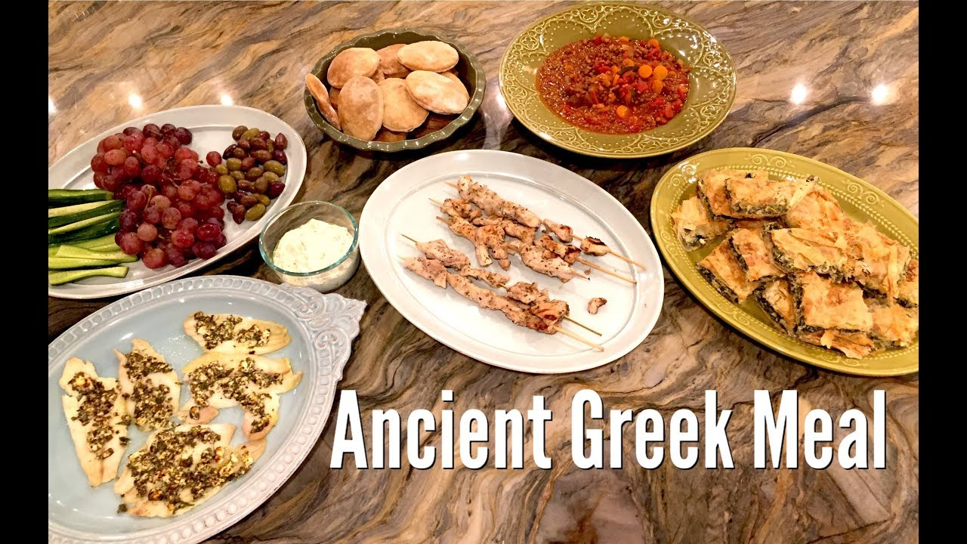 | Use the Ancient Greek alphabet to write a code.  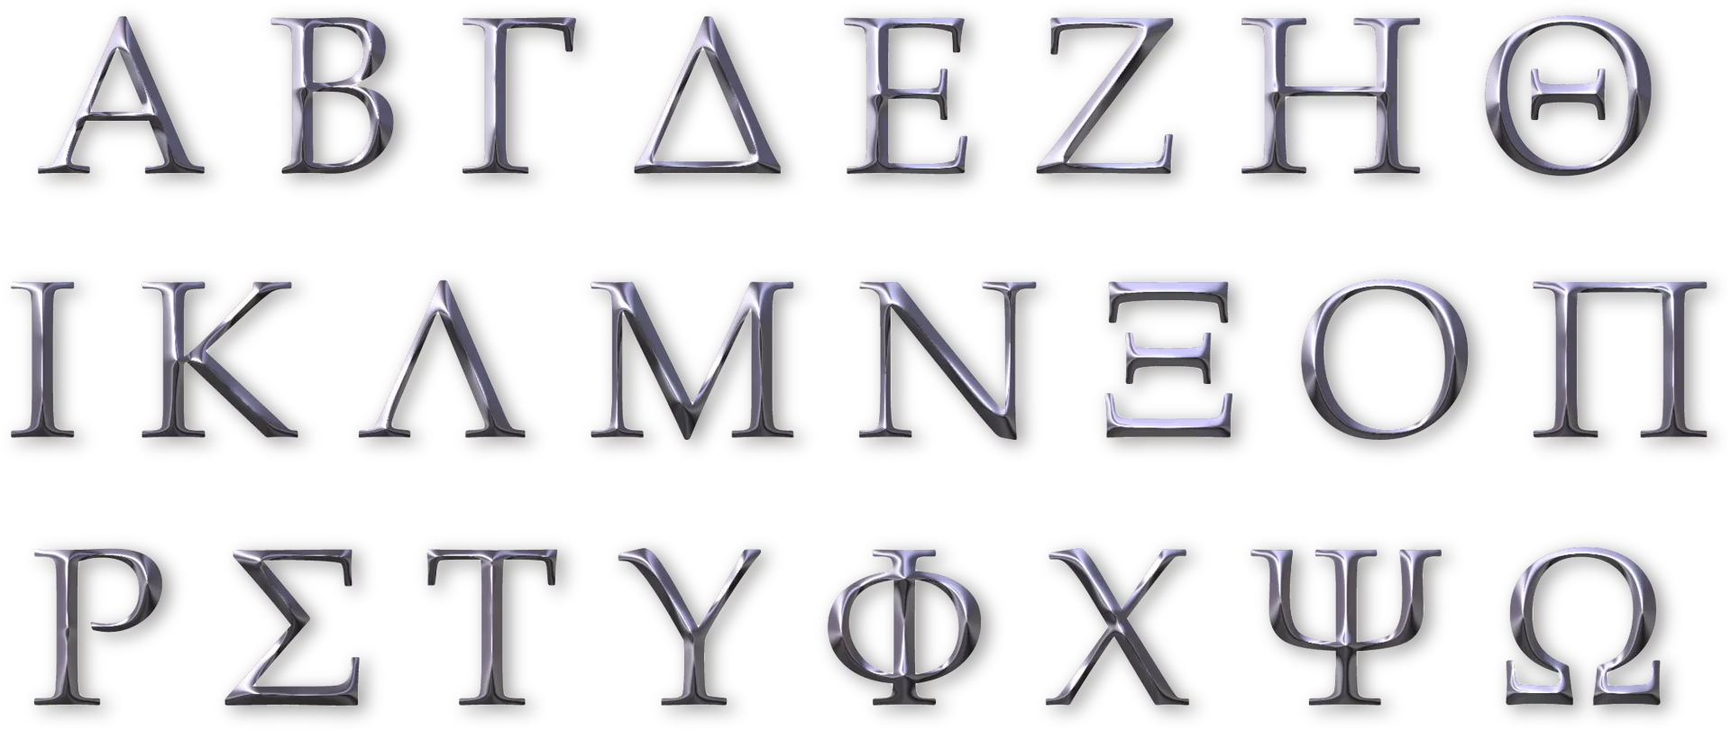 | Research the Greek Gods/Goddess’ and produce a slideshow about them. (One slide per God/Goddess)  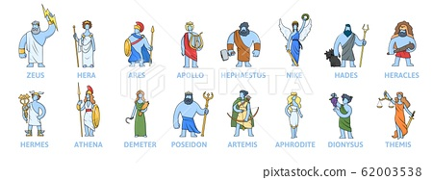 | Write an account of the Battle of Marathon  