**Physical Development**

* Continue to develop their movement, e.g. balancing, riding (scooters, trikes and bikes)
* Use large-muscle movements to wave flags and streamers, paint and make marks.
* Show a preference for a dominant hand.
* Develop a comfortable grip with good control when holding pens and pencils.
* Continue to develop independence in own care needs, e.g. doing up coats.

**Communication & Language**

* Enjoy listening to longer stories and can remember much of what happens.
* Know many rhymes, be able to talk about familiar books.
* Sing a large repertoire of songs.
* Develop their communication, through speech.
* Widen their vocabulary.

**Personal, Social & Emotional development**

* Become more outgoing with unfamiliar people, in the safe context of their setting.
* Increasingly follow rules, understanding why they are important.
* Do not always need an adult to remind them of a rule.
* Continue to talk about their feelings.
* Adapt to changes during and after Lockdown.

C:\Users\hwilliams.GHSCHOOL\AppData\Local\Microsoft\Windows\Temporary Internet Files\Content.IE5\FXP5PZHL\MC900368422[1].wmf

**Numbers**

* Develop understanding of numbers to 5.
* Show ‘finger numbers’ up to 5.
* Understand position through words alone.
* Discuss routes and locations, using words like ‘in front of’ and ‘behind’.
* Extend and create ABAB patterns – stick, leaf, stick, leaf.
* Develop mathematical language e.g. more, fewer, full, empty.

**Literacy**

* Letters and sounds ~ phonics phase 1
* Can name the different parts of a book.
* Spot and suggest rhymes.
* Continue to recognise words with the same initial sound.
* Recognise, trace and copy own name.
* Engage in extended conversations about stories.
* Traditional tales including; Sleeping Beauty, Three pigs, Gingerbread man, Three Billy Goats Gruff.

**Nursery**

**Term 4**

**Story time**

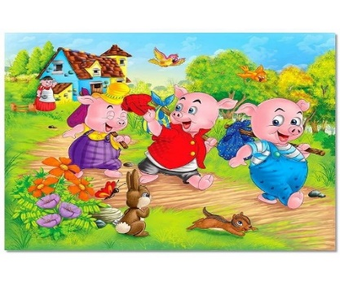

**Understanding the World**

* Spring watch and Outdoor learning.
* Celebrations including World book day, Mothers Day, Easter.
* Explore how things work.
* Explore and talk about different forces they can feel.
* Continue to to make sense of their own life-story and family’s history.

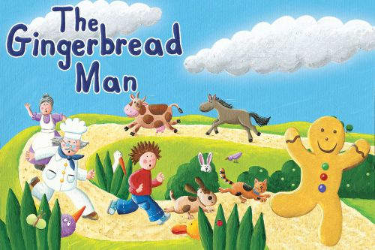

**Expressive Arts and Design**

* Explore different materials freely, in order to develop their ideas about how to use them and what to make.
* Begin to show different emotions in their drawings, like a sad face, happy face.
* Remember and sing entire songs.
* Sing the tune of familiar songs.
* Play instruments with increasing control.
* Experiment with different resources such as foam, finger paint, clay.