**Literacy**

Letters and sounds ~ phase 1 phonics.

Listen to, and join in with stories and poems.

Notice some print, such as the first letter of their name, a bus or door number, or a familiar logo.

Make marks on their picture for their name.

Understand that print has meaning

Recognise own name and match magnetic letters to their name.

World Nursery Rhyme week

Stories to include

The Three Bears.

Room on the broom.

The Nativity and other Christmas stories.

Non-fiction books.

**Physical Development**

Match their developing physical skills to tasks and activities in the setting.

Be increasingly independent in meeting their own care needs, e.g. brushing teeth, using the toilet, washing and drying their hands thoroughly.

Put on their coat independently.

Develop manipulation and control.

Use large and small motor skills to do things independently e.g. pour drinks.

**Communication and Language**

Develop speaking skills by building vocabulary and explaining thoughts.

Use a wider range of vocabulary

Can start a conversation with an adult or a friend and continue it for many turns.

Know many rhymes and songs

Begin to use talk to organise themselves in their play.

Listen to simple stories and understand what is happening, with the help of the pictures.

V

**Term 2**

**Understanding the World**

Explore the local environment.

Use all their senses in hands-on exploration of natural materials.

Notice signs of autumn.

Explore collections of materials with similar and/or different properties.

Show interest in different occupations.

Remember and talk about significant events in their own experience.

Celebrate events such as Bonfire night, Diwali, Remembrance, birthdays and Christmas.

 

**Personal, Social and Emotional Development**

Develop friendships with other children.

Select and use activities and resources, with help when needed.

Start to develop appropriate ways of being assertive.

Talk about their feelings in more elaborated ways: “I’m sad because...” or “I love it when ...”..

**Mathematics**

Recite numbers past 5.

Say one number for each item in order: 1,2,3,..

Experiment with their own symbols and marks for numerals.

Compare quantities e.g. ‘more’, ‘fewer’.

Compare sizes, weights etc. using gesture and language - ‘big/ little/smaller’, ‘high/low’, ‘tall’, ‘heavy’.

Notice patterns.

 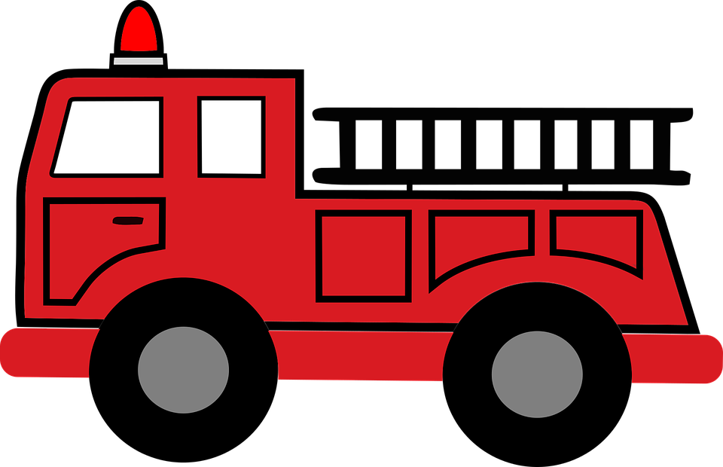

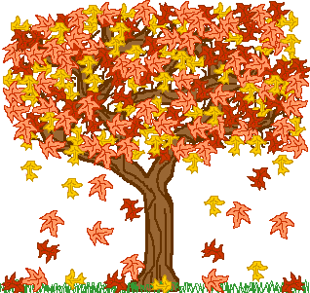  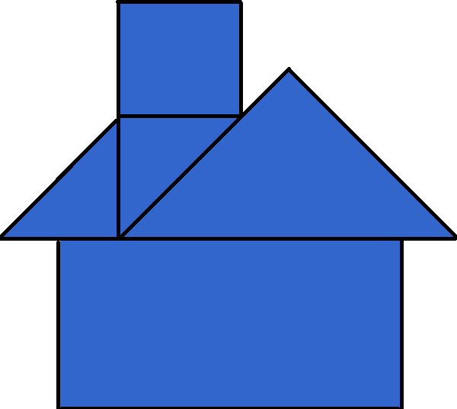

**Expressive arts and design**

Mark make (e.g. paint, chalk, crayons, fingers in foam or paint)

Make simple models which express their ideas.

Listen with increased attention to sounds.

Take part in simple pretend play, using an object to represent something else even though they are not similar.

Create closed shapes with continuous lines, and begin to use these shapes to represent objects.

Draw with increasing complexity and detail, such as representing a face with a circle and including details.

**Let’s talk about…..**

**Let’s celebrate!**