**Literacy**

* Letters and sounds ~ phonics phase 1
* Listen and join in with a range of stories.
* Engage in extended conversations about stories, learning new vocabulary.
* Recognise words with the same initial sound, such as money and mother.
* Understand that pages are sequenced.
* Books to include; Stickman, Elmer, Room on the broom, The Gruffalo, Owl babies.

**Communication & Language**

* Talk about familiar books.
* Develop their communication.
* Begin to say multisyllabic words such as ‘pterodactyl’ or ‘hippopotamus’.
* Respond to simple instructions.
* Use longer sentences of four to six words.
* Use a range of tenses.
* Understand a question or instruction that has two parts, such as “Get your coat and wait at the door”.

**Physical Development**

* Use a range of Nursery equipment.
* Go up steps and stairs, or climb up apparatus, using alternate feet.
* Hop, stand on one leg and hold a pose for a game like musical statues.
* Choose the right resources to carry out their own plan e.g. use a trowel.
* Use one-handed tools e,g, scissors.
* Increase independence e.g. coats and zips.
* Begin to hold a pencil with the tripod grip.
* Cooking e.g. Gingerbread men.

C:\Users\hwilliams.GHSCHOOL\AppData\Local\Microsoft\Windows\Temporary Internet Files\Content.IE5\FXP5PZHL\MC900368422[1].wmf

**Mathematics**

* Fast recognition of up to 3 objects, without having to count them individually (‘subitising’).
* Know that the last number reached when counting tells you how many there are in total (‘cardinal principle’).
* Solve real world problems to 5.
* Talk about and explore 2D shapes.
* Describe a familiar route.
* Talk about and identify the patterns around them.

**Personal, Social & Emotional development**

* Grow in independence.
* Begin to develop their sense of responsibility and membership of a community.
* Talk about their feelings using words like ‘happy’ or ‘sad’.
* Develop appropriate ways of being assertive.
* Take turns and share resources.

**Nursery**

**Term 3**

**It’s storytime**

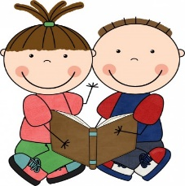

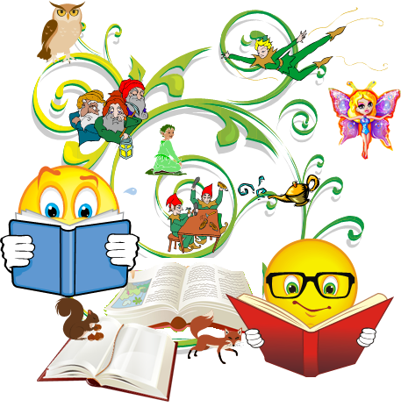

**Expressive Arts and Design**

* Draw, paint and make models.
* Explore colours and textures.
* Begin to develop complex stories using small world toys such as animals and dolls houses.
* Respond to what they have heard, expressing their thoughts and feelings.
* Use drawing to represent ideas e.g. fireworks.
* Experiment with different resources.

**Understanding the World**

* Winter watch and wellie walks.
* Celebrations such as Chinese New Year.
* Begin to make sense of their own life-story and family’s history.
* Recognise and describe special times.
* Talk about the differences between materials and changes they notice.