**Communication & Language**

* Listen to stories.
* Join in with repeated refrains and anticpate key events.
* Respond to simple instructions.
* Can retell an event in the correct order.
* Understand ‘ who, what, when, why and how’.
* Use a range of tenses.

**Literacy**

* Letters and sounds ~ phonics phase 1
* Listen and join in with a range of stories.
* Describe main story settings, characters and events.
* Begin to create marks for writing.
* Books; Traditional tales e.g., Three little pigs, Gingerbread man, Sleeping Beauty.

**Physical Development**

* Use a range of Nursery equipment including hoops and balls.
* Move in different ways.
* Regularly use the correct pencil grip.
* Become aware of physical feelings such as tiredness or hunger.
* Cooking e.g. Gingerbread men.

C:\Users\hwilliams.GHSCHOOL\AppData\Local\Microsoft\Windows\Temporary Internet Files\Content.IE5\FXP5PZHL\MC900368422[1].wmf

**Nursery**

**Term 3**

**It’s storytime**

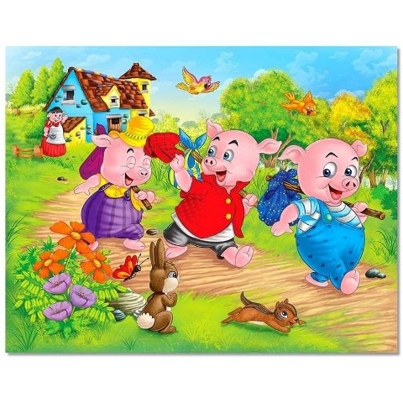

**Numbers**

* Compare sets with the same amount.
* Match objects to a number e.g 3 bears.
* Count claps, stamps and steps.
* Begin to solve number problems.

**Shape, Space and Measures**

* Show an interest in shapes.
* Understand and use position words such as ‘behind’, ‘on top’, ‘next to’ ‘under’.
* Find shapes in the environment.

**Personal, Social & emotional development**

* Keep play going by responding to what others are saying or doing.
* Confidently talk to other children when playing and communicate freely about home and community.
* Begin to accept the needs of others.
* Take turns and share resources.
* New children in Nursery (new friends).

**Understanding the World**

* Winter watch and wellie walks.
* Celebrations such as Chinese New Year.
* Operate simple ICT equipment.
* Recognise and describe special times.
* Can talk about some of the things they have observed.

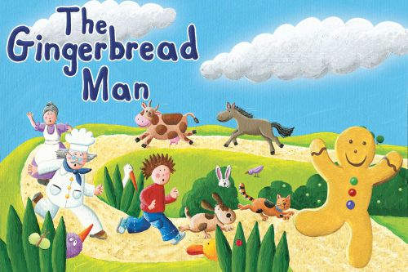

**Expressive arts and design**

* Dressing up.
* Use collage and talk about textures.
* Model making.
* Paint and draw.
* Sing and make music.
* Copy simple rhythms.
* Experiment with resources such as gel, paint, foam, porridge.