**Literacy**

* Letters and sounds ~ phonics phase 1
* Pay attention and respond to the pictures or the words.
* Begin to ask questions about the book.
* Join in with songs and rhymes, copying sounds, rhythms, tunes and tempo.
* Enjoy drawing freely.
* Books; Stickman, Room on the Broom, Elmer, The Gruffalo.

**Physical Development**

* Use a range of Nursery equipment including trikes, rockers and the slide.
* Clap and stamp to music.
* Develop whole body movements e.g. spin or roll.
* Begin to develop a good pencil grip.
* Put on their own coat and attempt to use the zip.
* Cooking e.g. Gingerbread men.

**Communication & Language**

* Develop their communication.
* Start to develop conversation, often jumping from topic to topic.
* Listen to simple stories and understand what is happening, with the help of the pictures.
* Develop pretend play: ‘putting the baby to sleep’ or ‘driving the car to the shops’.
* Understand and act on longer sentences like ‘make teddy jump’ or ‘find your coat’.

C:\Users\hwilliams.GHSCHOOL\AppData\Local\Microsoft\Windows\Temporary Internet Files\Content.IE5\FXP5PZHL\MC900368422[1].wmf

**Nursery**

**(Younger children)**

**Term 3**

**It’s storytime**

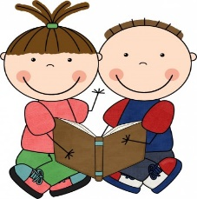

**Mathematics**

* Take part in finger rhymes with numbers.
* Count in everyday contexts
* Build with a range of resources.
* Talk about and explore 2D shapes.
* Understand and use position words such as ‘behind’, ‘on top’, ‘next to’ ‘under’.
* Notice patterns.

**Personal, Social & Emotional development**

* Grow in independence.
* Safely explore emotions beyond their normal range through play
* Feel strong enough to express a range of emotions.
* Notice and ask questions about differences.
* Take turns and share resources.

**Expressive Arts and Design**

* Move and dance to music.
* Use collage and talk about textures.
* Start to make marks intentionally.
* Paint and draw.
* Start to develop pretend play.
* Make simple models which express their ideas.
* Experiment with resources such as gel, paint, foam, porridge.

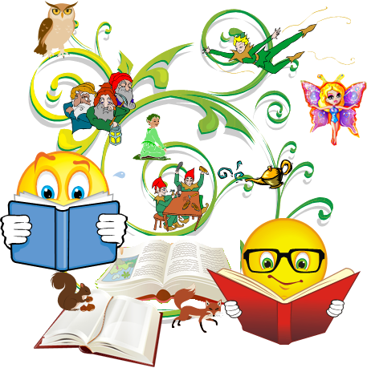

**Understanding the World**

* Winter watch and wellie walks.
* Celebrations such as Chinese New Year.
* Explore materials with different properties.
* Begin to make connections between the features of their family and other families.
* Can talk about some of the things they have observed.