Extreme Earth Homework
Create an advice leaflet outlining what to do should a volcano erupt.  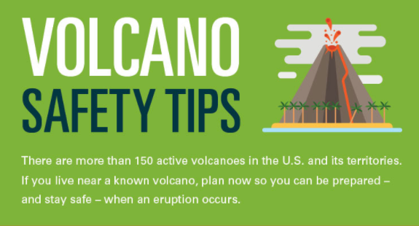 | Draw a picture of a volcano scene  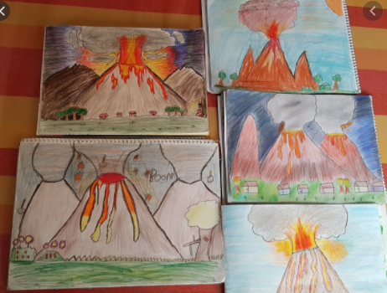 | 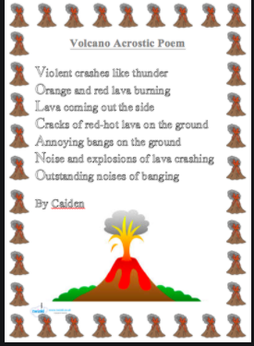  Write an acrostic poem using the letters from the word ‘VOLCANO’ | 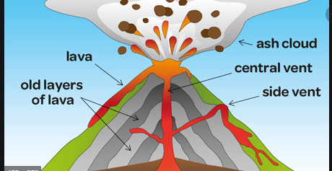  Fact page about volcanoes or Pompeii | Create a fact file or poster about how Earthquakes happen  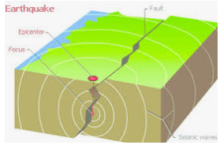 | Create a leaflet about what to do in an earthquake.  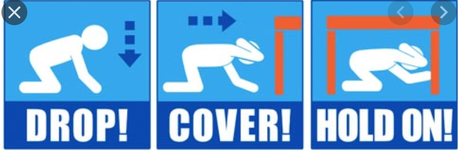
Make a 3D volcano model  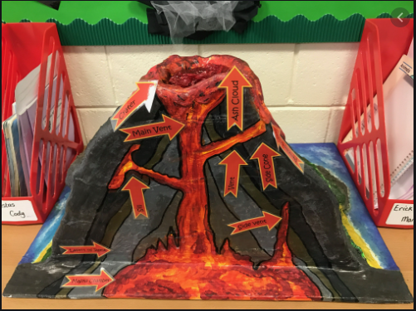 | 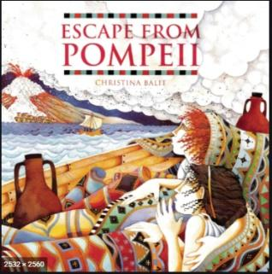  Write an adventure story set around a volcanic eruption / Pompeii | Research and present findings in your own words about different types of volcanoes  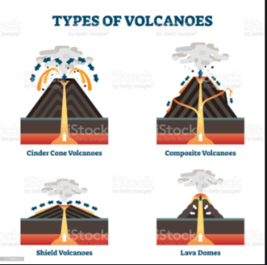 | Create a board game inspired by volcanoes  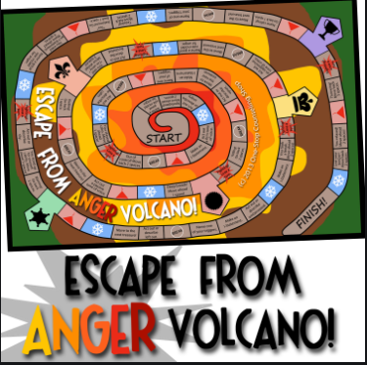 | Write an explanation text about the Richter scale.  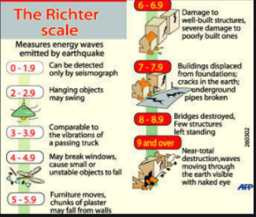 | Create a story about an Earthquake.  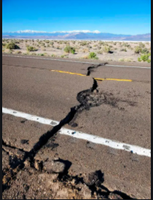
Pick four Extreme Earth project homework tasks and earn house points for each completed project.
Hand in date – Wednesday 10th February. We look forward to seeing your creations!
Miss Jessop and Mrs Keye

