Crime and Punishment Homework!
Pick 3 of these projects to complete and earn a house point for each project. Bring your projects in on Wednesday 9th December.
Create a Tudor Rose in any art media of your choice.  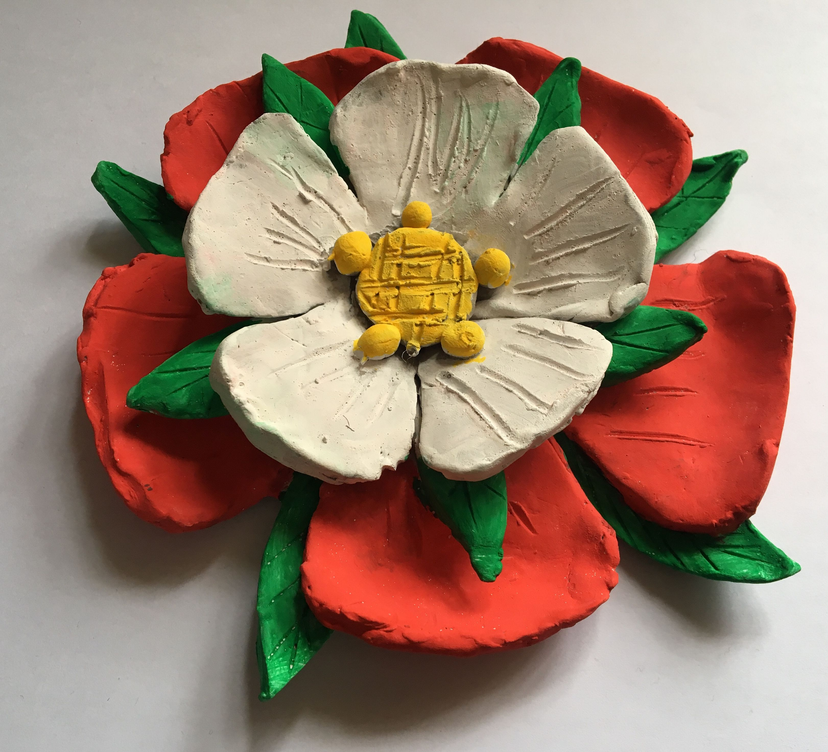 | Create a piece of art based on Oliver Twist  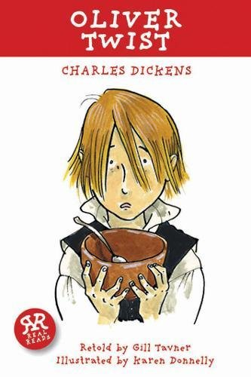 | If you could make a Law to apply now, what would it be and why? | Fact file on Henry VIII.  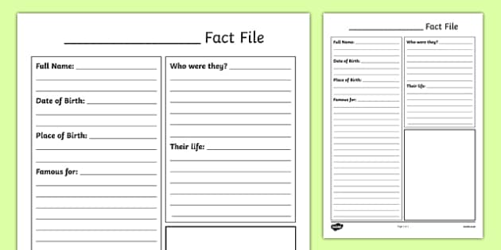
Read or watch Oliver Twist.  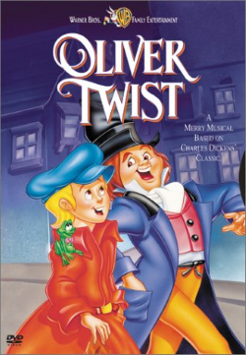 | Draw a portrait of Henry VIII.  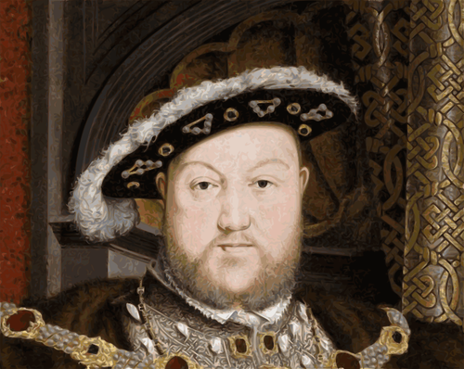 | Compare Queen Victoria and Henry VIII.  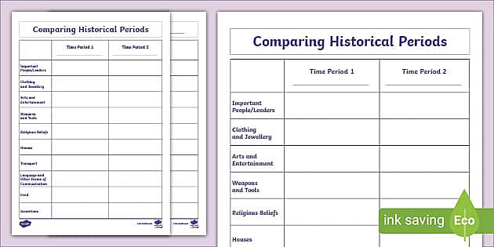 | Create a poem about Henry VIII wives.  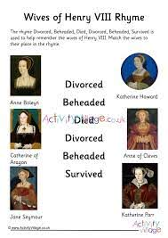
Draw a portrait of Queen Victoria.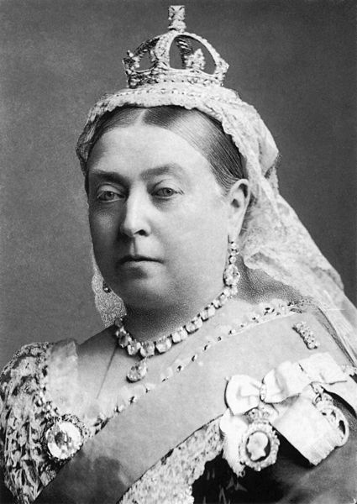 | Write the instructions and make a Victoria Sponge (send in pictures).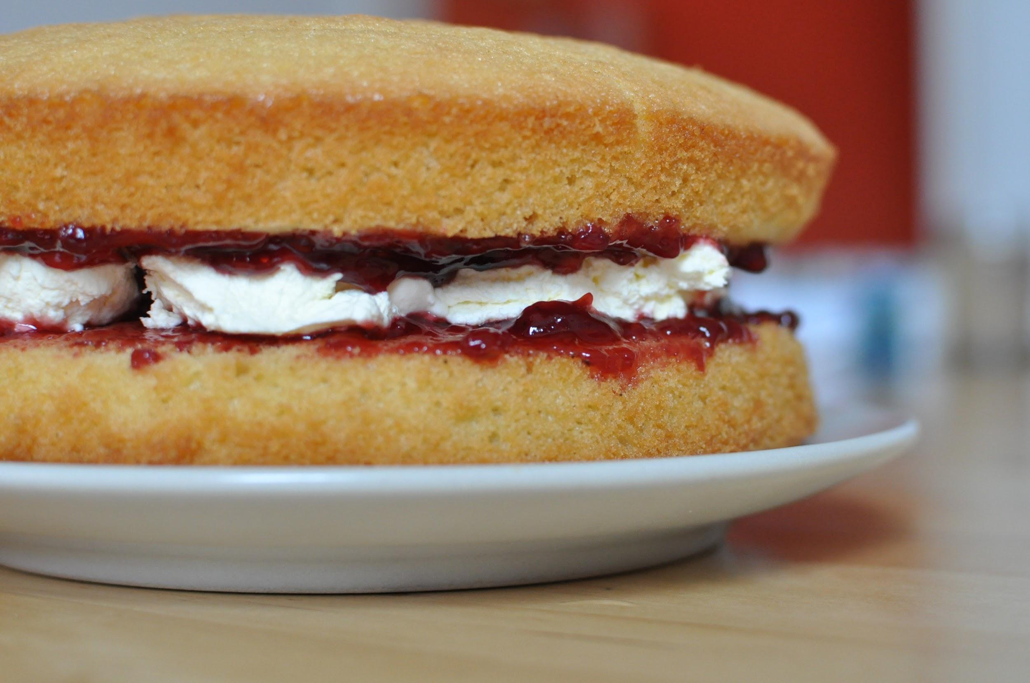 | Research about the Victorian workhouses. 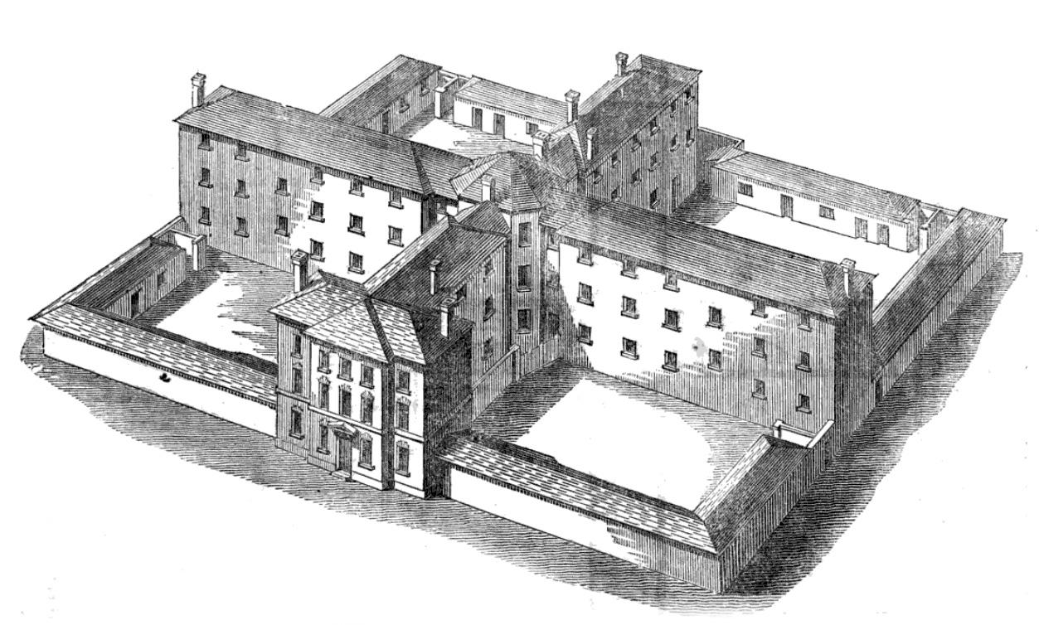 | Create a family tree of the Royal Family. How far back can you go?
If you could create a punishment for a crime, what would it be and why?  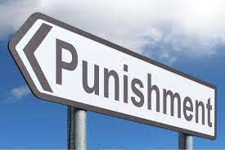 | Write a fact file on any Monarch of your choice. | Compare what life was like between Queen Victoria and Queen Elizabeth I. 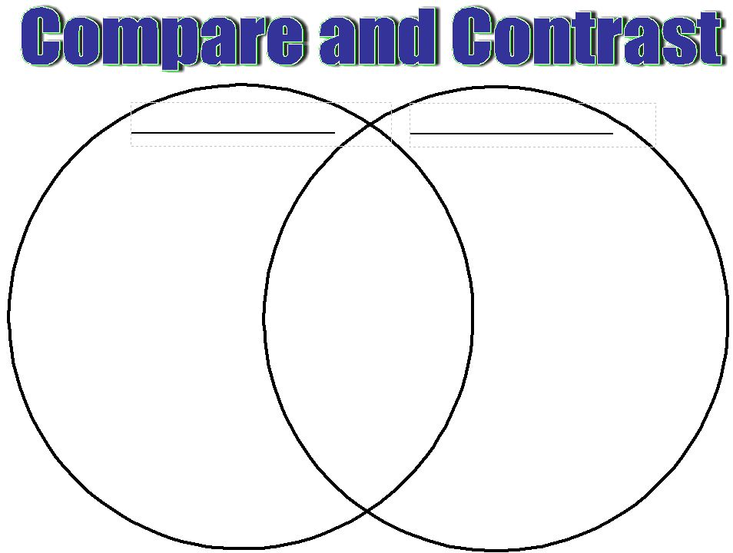 | Make a bowl of gruel to try.