‘Brilliant Britain’ Homework Term 4
Build a bug hotel.  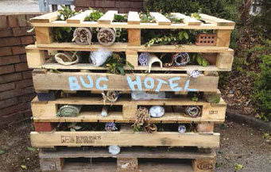  https://www.rspb.org.uk/get-involved/activities/give-nature-a-home-in-your-garden/garden-activities/build-a-bug-hotel/ | Make a toilet roll bird feeder.  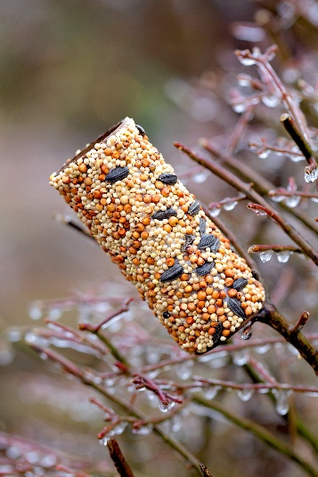 | Go on a nature walk near where you live. Take photos of what you find on your walk or draw what you saw. 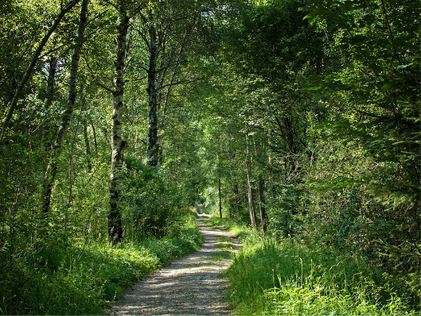 | Create a fact file about a famous British person or landmark.  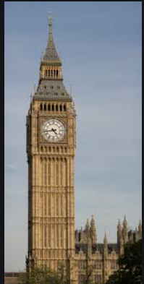
Make a British meal or dish and write instructions on how to make it and take photos. | Write an acrostic poem using the words ‘Brilliant Britain.’ | Have a traditional afternoon tea. Take photos and simply enjoy it!  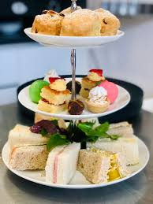 | Create a poster all about what makes Britain brilliant.  You could include things such as:  - The NHS  - Royal Family  - Places to visit  - Food  and anything else that you think makes Britain brilliant.

