Animals Homework
Our book this term is Fantastic Mr Fox by Rohld Dahl. This book is illustrated by Quentin Blake- can you use this link to try and draw like him  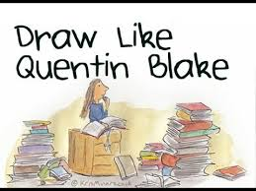  https://www.youtube.com/watch?v=g0zB2DI_hgw | Write a fact file all about foxes  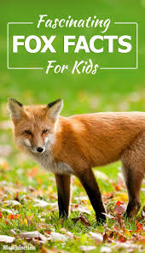 | Dance like an animal  https://www.youtube.com/watch?v=JItkRLVlf-c | Create a microhabitat in your garden  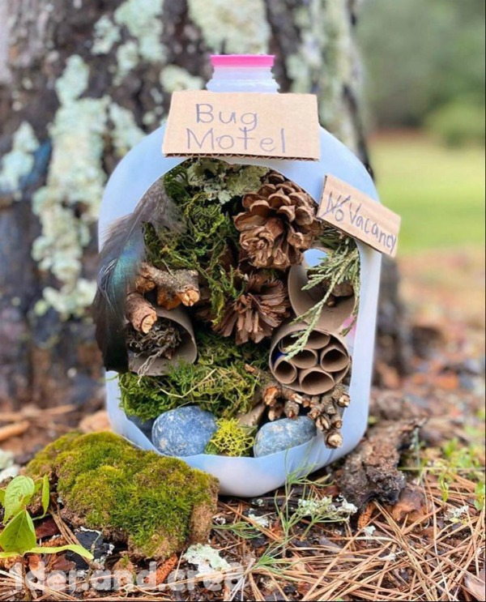
Build an animal using junk modelling.  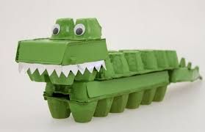 | Why not try some animal yoga!  https://www.youtube.com/watch?v=s-Z127YfUQo  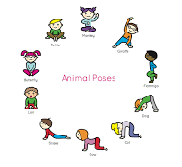 | Do a wildlife survey.  Spend an hour outside somewhere and keep track of all the wildlife you see. Which was the most popular? Which did you see the least?  Which animal were you surprised to see? | Act out the Fantastic Mr Fox story as one of the characters and film yourself!
Make animal shaped snacks  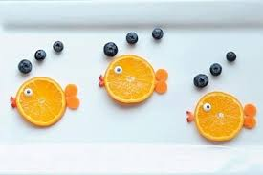  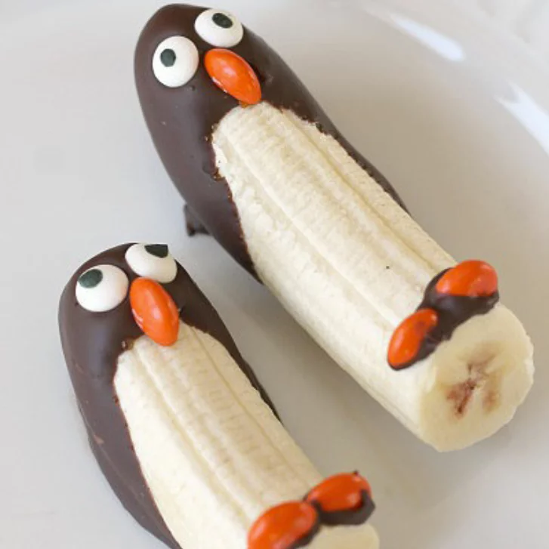 | Have a go at making a bird feeder to hang outside.  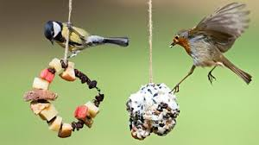 | Make a paper plate fox  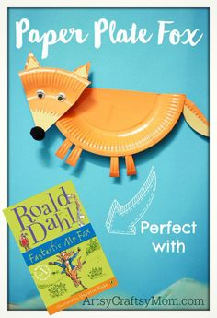 | Sculpt a model of a character from Fantastic MR Fox.  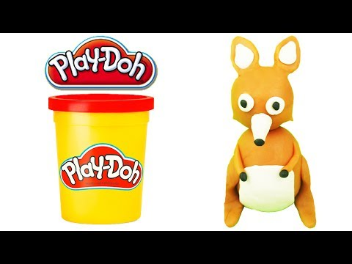
Learn about the habitat of a fox  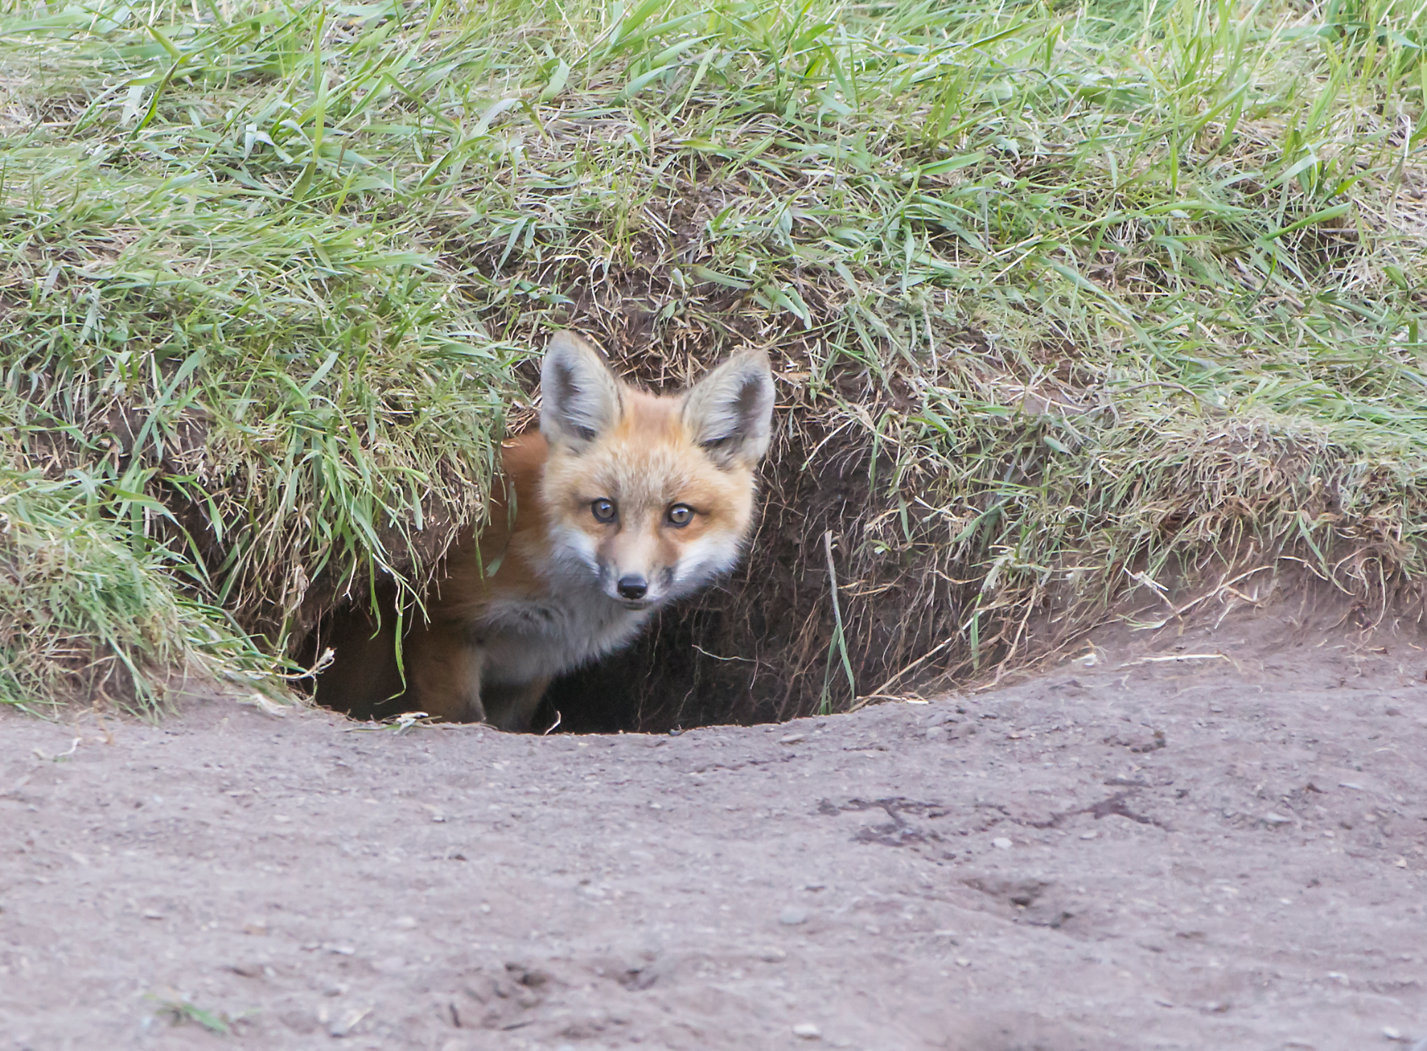 | Paint your favourite animal  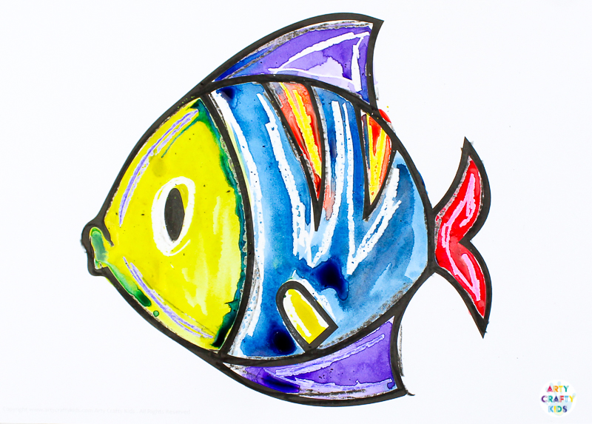 | Make up a song about an animal.  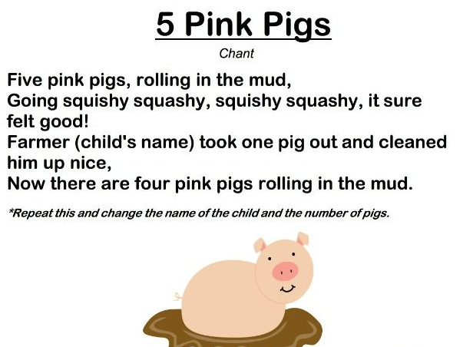 | Bake animal biscuits  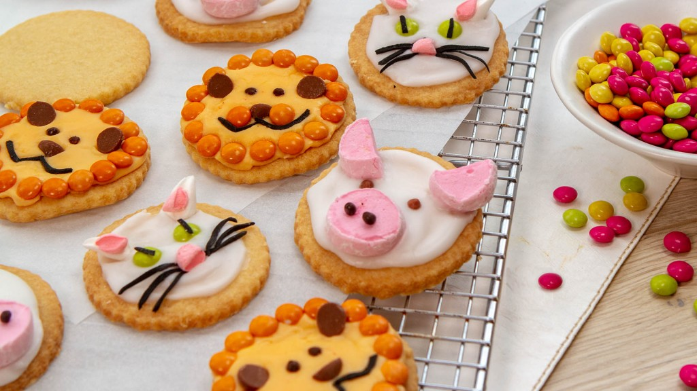
Pick four (or more) Animal project homework tasks and earn 10 dojo’s per completed project.
Please send us pictures on Dojo once a task has been completed! We look forward to seeing your creations!
Mrs Crane and Miss Bickle

